### 1 [CENTRAL LIBRARY IIT BOMBAY | HOME](http://www.library.iitb.ac.in/) – (India)

[http://iitb.summon.serialssolutions.com/?#!/search?ho=f&fvf=ContentType,Newspaper%20Article,t%7CContentType,Conference%20Proceeding,f%7CContentType,Electronic%20Resource,f%7CContentType,Journal%20%2FeJournal,f%7CContentType,Journal%20Article,f%7CContentType,BookChapter,f%7CContentType,Dissertation,f%7CContentType,Trade%20Publication%20Article,f&rf=PublicationDate,2011:*&l=en&q=dislessia%20e%20riabilitazione](http://iitb.summon.serialssolutions.com/?#!/search?ho=f&fvf=ContentType,Newspaper%20Article,t%7CContentType,Conference%20Proceeding,f%7CContentType,Electronic%20Resource,f%7CContentType,Journal%20%2FeJournal,f%7CContentType,Journal%20Article,f%7CContentType,BookChapter,f%7CContentType,Dissertatio)

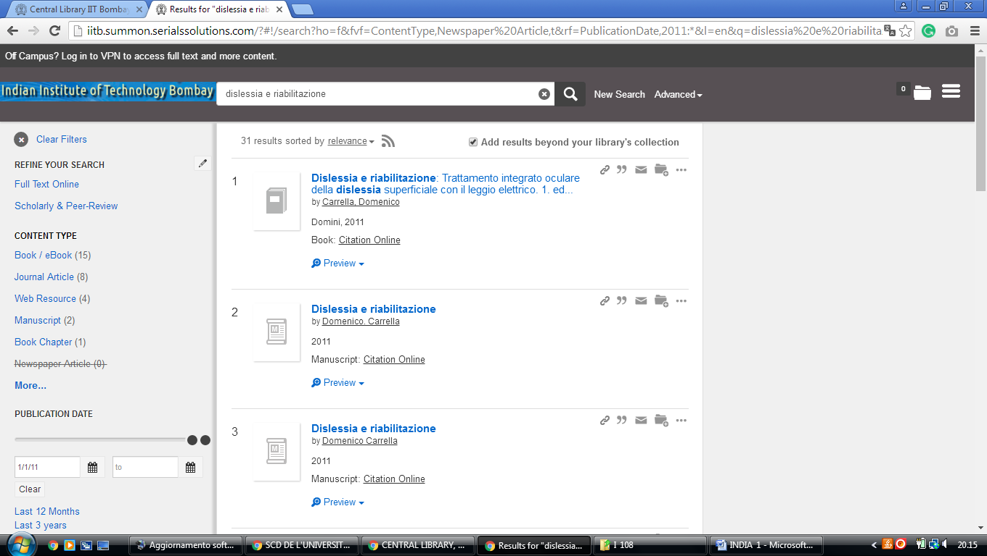

### 2 [MAULANA AZAD LIBRARY - ALIGARH MUSLIM UNIVERSITY](https://www.amu.ac.in/malibrary/) – (Amu Campus, Aligarh, Uttar Pradesh, India)

<http://eds.b.ebscohost.com/eds/detail/detail?vid=2&sid=5a993dc9-3666-4b18-b5f8-bc6815fdc53e%40pdc-v-sessmgr01&bdata=JkF1dGhUeXBlPWlwLHVpZCZsYW5nPWZyJnNpdGU9ZWRzLWxpdmUmc2NvcGU9c2l0ZQ%3d%3d#AN=edsfis.959441&db=edsfis>

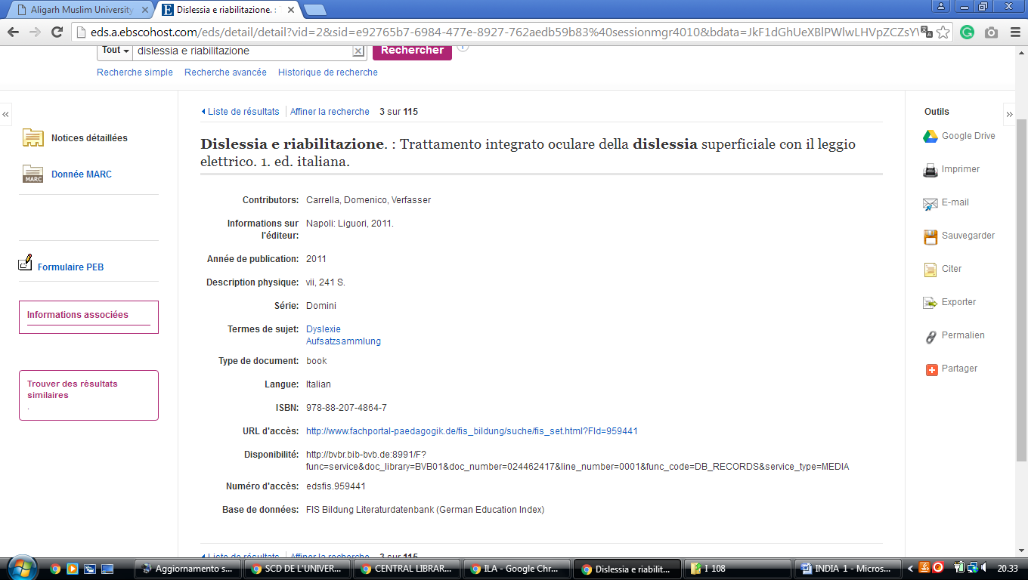

### 3 [IGNOU - LIBRARY AND DOCUMENTATION DIVISION (LDD) - INTRODUCTION](http://www.ignou.ac.in/ignou/aboutignou/division/ldd/introduction) - (Indira Gandhi National Open University, India)

<http://eds.a.ebscohost.com/eds/results?vid=4&sid=4897c80a-2a03-43dc-93de-1cb9d13a00ff%40sessionmgr4009&bquery=(dislessia+AND+e+AND+riabilitazione)&bdata=JkF1dGhUeXBlPWlwLHVpZCZsYW5nPWZyJnR5cGU9MCZzaXRlPWVkcy1saXZlJnNjb3BlPXNpdGU%3d>

