**ISLANDS NATIONAL UNIVERSITY HONIARA, Solomon,**  [**ISLANDS**](https://en.wikipedia.org/wiki/Solomon_Islands)

[About SINU – SINU](https://www.google.com/url?sa=t&rct=j&q=&esrc=s&source=web&cd=2&cad=rja&uact=8&ved=2ahUKEwjLq_K6iILpAhWj5KYKHRjuAtsQFjABegQIARAB&url=http%3A%2F%2Flibrary.sinu.edu.sb%2F&usg=AOvVaw02_r8UMygt-RTrHc08Blk1)

[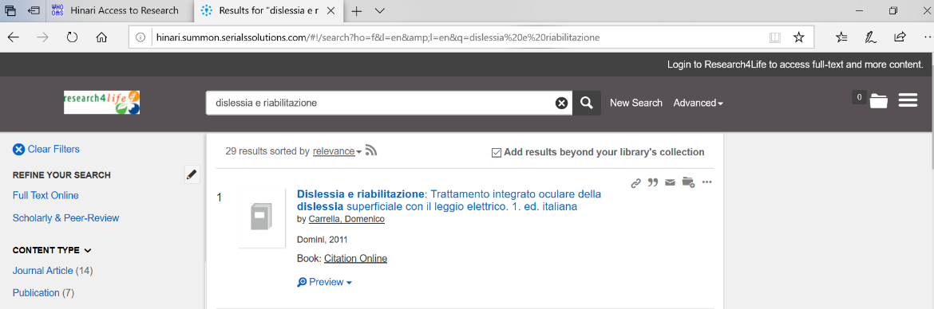](https://www.google.com/url?sa=t&rct=j&q=&esrc=s&source=web&cd=2&cad=rja&uact=8&ved=2ahUKEwjLq_K6iILpAhWj5KYKHRjuAtsQFjABegQIARAB&url=http%3A%2F%2Flibrary.sinu.edu.sb%2F&usg=AOvVaw02_r8UMygt-RTrHc08Blk1)