**UNIVERSITY OF GUYANA LIBRARY**

[University of Guyana Library catalog](https://www.google.com/url?sa=t&rct=j&q=&esrc=s&source=web&cd=1&cad=rja&uact=8&ved=2ahUKEwi7_-XAgP3oAhUpUhUIHfaIB8QQFjAAegQIBBAB&url=https%3A%2F%2Flibrary.uog.edu.gy%3A81%2F&usg=AOvVaw2MdXFtMUpeLD3_2n66YKGY&cshid=1587591893329311)

[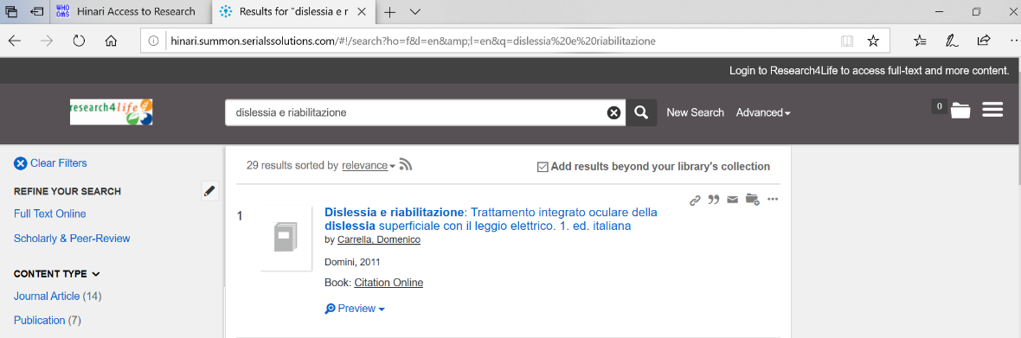](https://www.google.com/url?sa=t&rct=j&q=&esrc=s&source=web&cd=1&cad=rja&uact=8&ved=2ahUKEwi7_-XAgP3oAhUpUhUIHfaIB8QQFjAAegQIBBAB&url=https%3A%2F%2Flibrary.uog.edu.gy%3A81%2F&usg=AOvVaw2MdXFtMUpeLD3_2n66YKGY&cshid=1587591893329311)