[**Athens**](https://librarytechnology.org/libraries/search.pl?City=Athens&Country=Greece)**, National Library of GRECIA**

[**Εθνική Βιβλιοθήκη της Ελλάδος | National Library of Greece**](https://www.google.com/url?sa=t&rct=j&q=&esrc=s&source=web&cd=1&cad=rja&uact=8&ved=2ahUKEwj2q5L83YvoAhVrkosKHfgJD_UQFjAAegQIARAC&url=https%3A%2F%2Fwww.nlg.gr%2F&usg=AOvVaw2q1CMLHX90L_6-uLK2AfhT)

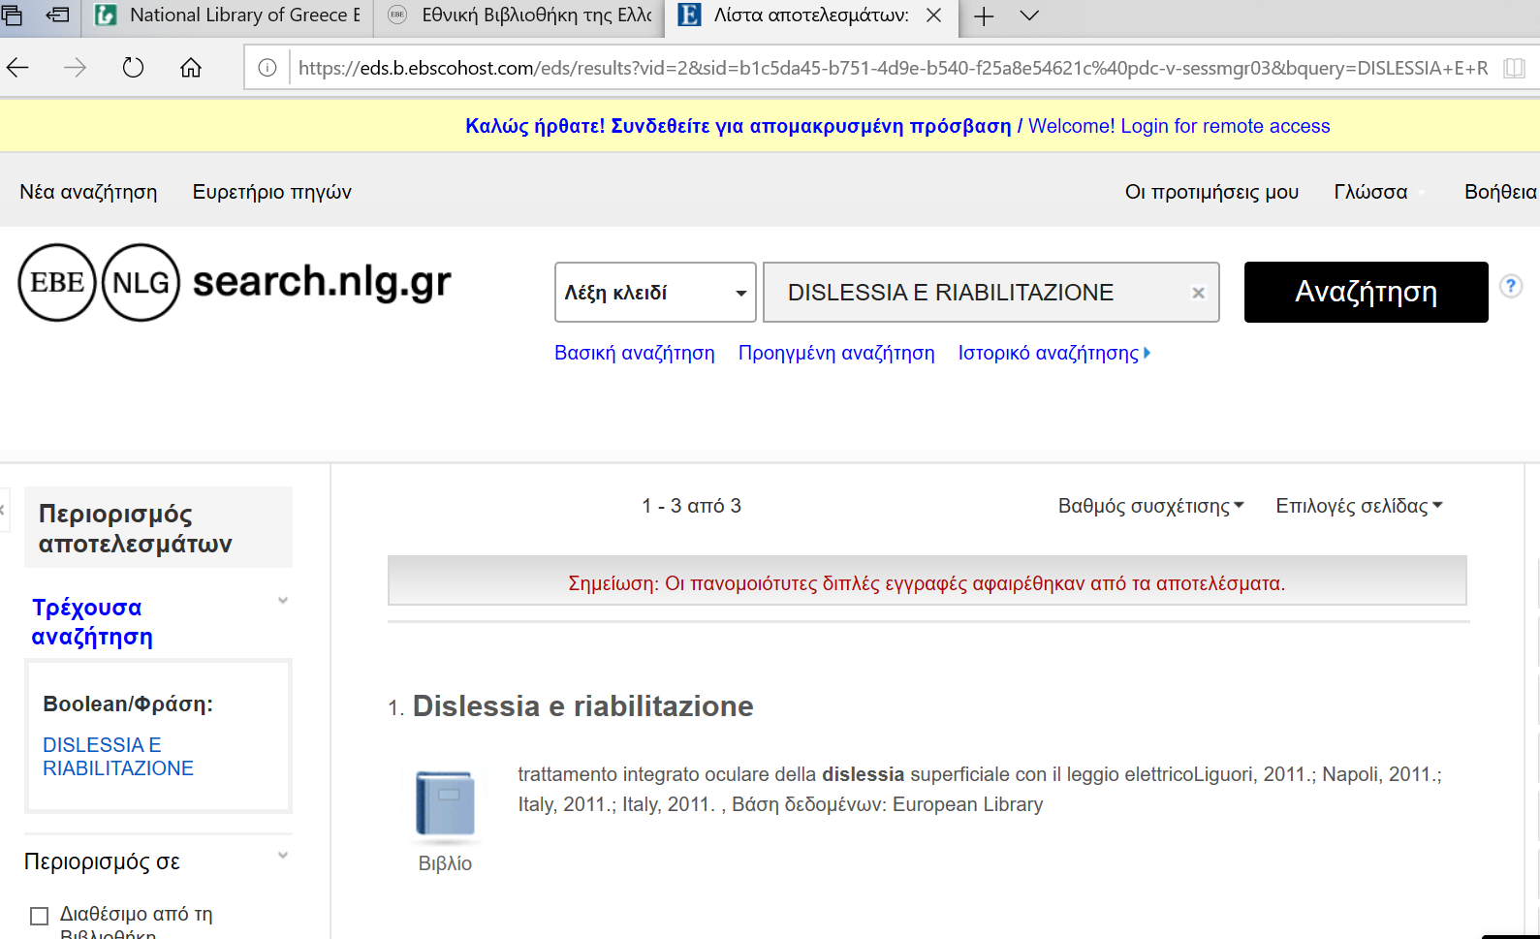

|  |  |
| --- | --- |
|  | **National and Kapodistrian University of Athens** |

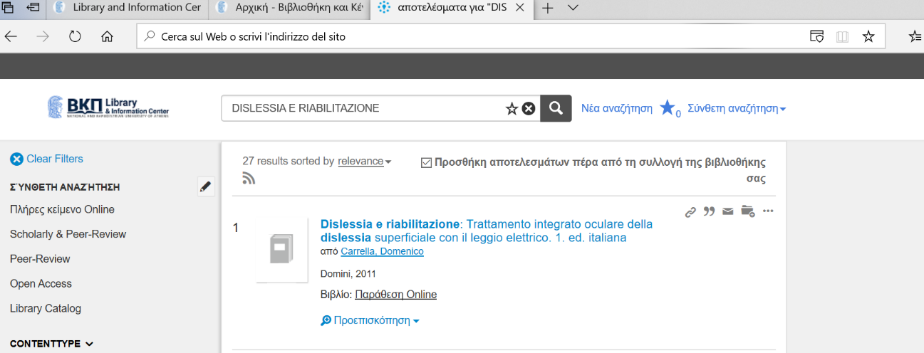[https://nkua.summon.serialssolutions.com/gr-GR/search?ho=t&q=DISLESSIA%20E%20RIABILITAZIONE#!/search?ho=f&l=gr-GR&q=DISLESSIA%20E%20RIABILITAZIONE](https://nkua.summon.serialssolutions.com/gr-GR/search?ho=t&q=DISLESSIA%20E%20RIABILITAZIONE%23!/search?ho=f&l=gr-GR&q=DISLESSIA%20E%20RIABILITAZIONE)

[**The American College of Greece | Library**](https://www.google.com/url?sa=t&rct=j&q=&esrc=s&source=web&cd=14&cad=rja&uact=8&ved=2ahUKEwii1-WsobHoAhVSxKYKHYP0BRE4ChAWMAN6BAgEEAE&url=https%3A%2F%2Fwww.acg.edu%2Fgraduate%2Fschool-of-graduate-professional-education%2Flibrary%2F&usg=AOvVaw1wANC3nSJZBz2LeT7MdYsu)

https://acg.on.worldcat.org/search?queryString=DISLESSIA%20E%20RIABILITAZIONE&databaseList=1080,2375,2175,3384,1082,1910,1931,1996,1875,2007,2006,2069,2267,2784,1672,3036,638,1913,10874,4162,2264,2263,2483,2262,2482,2261,1271,2260,10008,3548,2513,1842,2259,1621,2237,2277,1609,1708,3643&sortKey=BEST_MATCH&clusterResults=true&scope=&format=Book&format=Audiobook&page=1

