**1**  [**NATIONAL AND PARLIAMENTARY LIBRARY OF GEORGIA - THE EUROPEAN LIBRARY**](http://www.theeuropeanlibrary.org/tel4/contributor/P01248)

<http://www.theeuropeanlibrary.org/tel4/contributor/P01248>

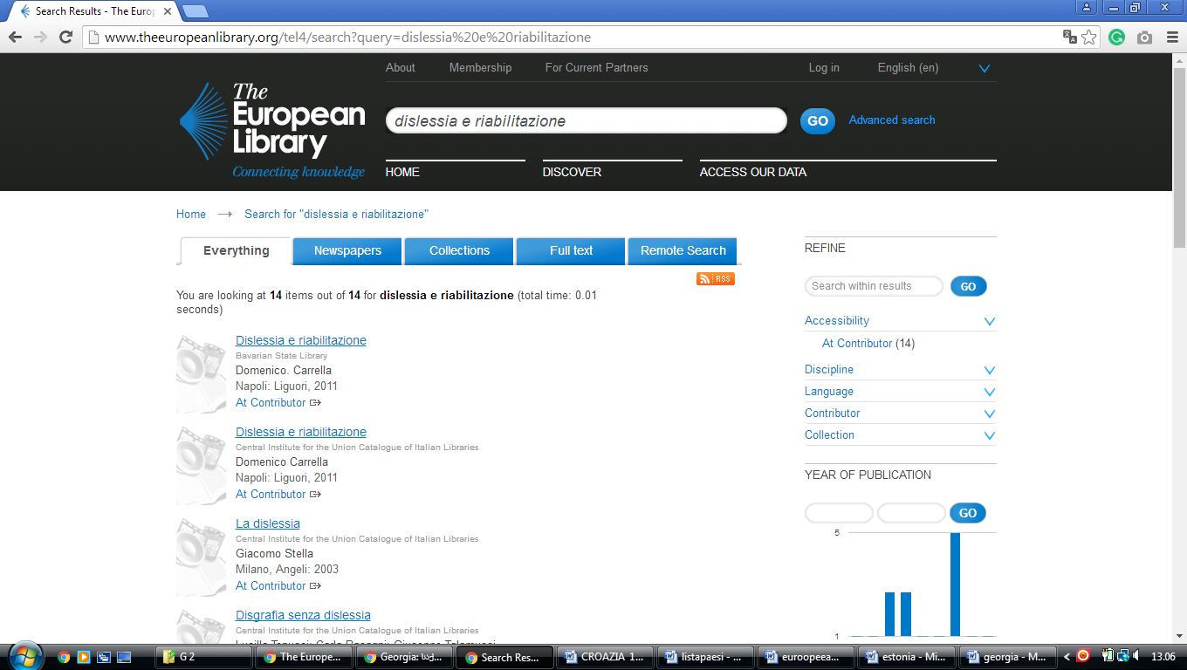

[**Philadelphia College of Osteopathic Medicine – Georgia campus**](http://www.pcom.edu/Library/index.php)

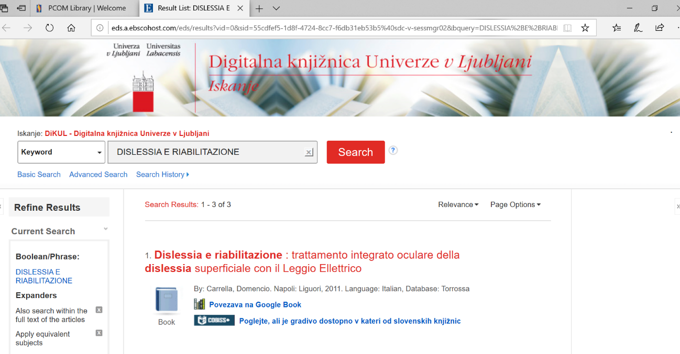

**University Libraries,** [Georgia](https://en.wikipedia.org/wiki/Georgia_(U.S._state))

<https://eds.a.ebscohost.com/eds/results?vid=0&sid=46ce7a7e-9e5a-4d51-b6a3-ba2339594c13%40sdc-v-sessmgr01&bquery=dislessia%2be%2briabilitazione&bdata=JkF1dGhUeXBlPWlwLHNoaWImY2xpMD1GVDEmY2x2MD1ZJnR5cGU9MCZzZWFyY2hNb2RlPUFuZA%3d%3d>

