**EUCLID UNIVERSITY. Euclid,** [**GAMBIA**](https://www.turismo.it/oltreconfine/scheda/gambia/)

[Project Euclid - University Library](https://www.google.com/url?sa=t&rct=j&q=&esrc=s&source=web&cd=2&cad=rja&uact=8&ved=2ahUKEwjRpvPaxczoAhXFAxAIHSY8Ap4QFjABegQIBxAB&url=https%3A%2F%2Fwww.ru.nl%2Flibrary%2Fsearch%2Fdatabases%2Fdatabases%2Finformation%2Finformation-project%2F&usg=AOvVaw2Np95OsnskmMad-dZ-KiBZ)

[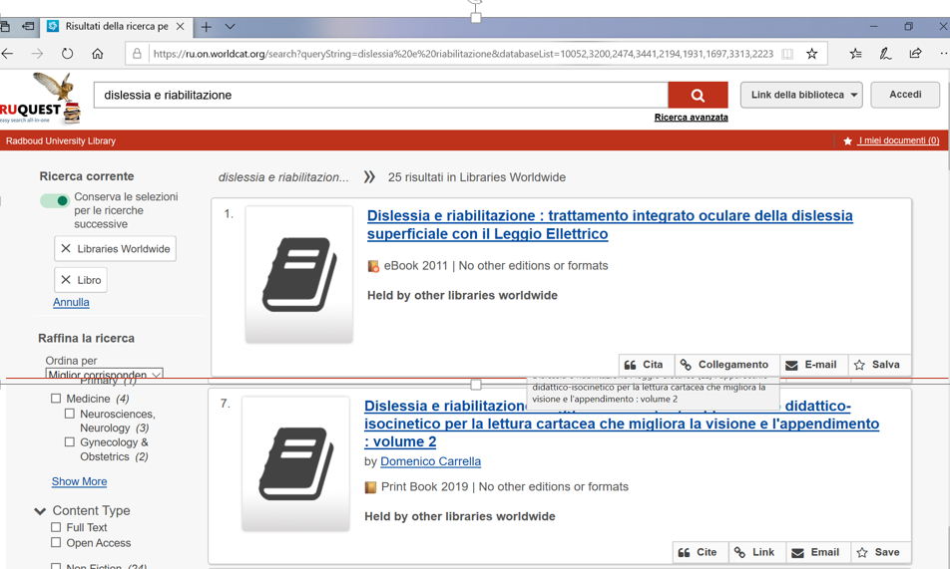](https://www.google.com/url?sa=t&rct=j&q=&esrc=s&source=web&cd=2&cad=rja&uact=8&ved=2ahUKEwjRpvPaxczoAhXFAxAIHSY8Ap4QFjABegQIBxAB&url=https%3A%2F%2Fwww.ru.nl%2Flibrary%2Fsearch%2Fdatabases%2Fdatabases%2Finformation%2Finformation-project%2F&usg=AOvVaw2Np95OsnskmMad-dZ-KiBZ)