**1** [**RIZAL LIBRARY**](http://rizal.lib.admu.edu.ph/) **– (**Quezon City, Filippine)

<http://eds.b.ebscohost.com/eds/results?vid=0&sid=7ca7c488-4ec4-48dc-8790-5f612e8e0797%40sessionmgr104&bquery=dislessia+e+riabilitazione&bdata=JnR5cGU9MCZzY29wZT1zaXRl>

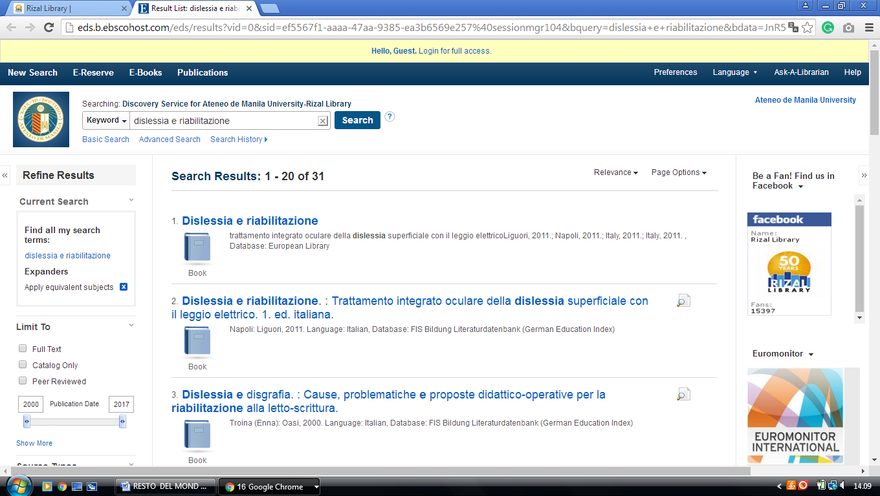

### 2 [UNIVERSITY OF THE PHILIPPINES LOS BAÑOS UNIVERSITY LIBRARY](https://library.uplb.edu.ph/), (Filippine)

<http://eds.a.ebscohost.com/eds/results?vid=0&sid=54668f69-e203-4ba3-afc1-c87917214c9c%40sessionmgr4006&bquery=dislessia+e+riabilitazione&bdata=JnR5cGU9MCZzaXRlPWVkcy1saXZl>

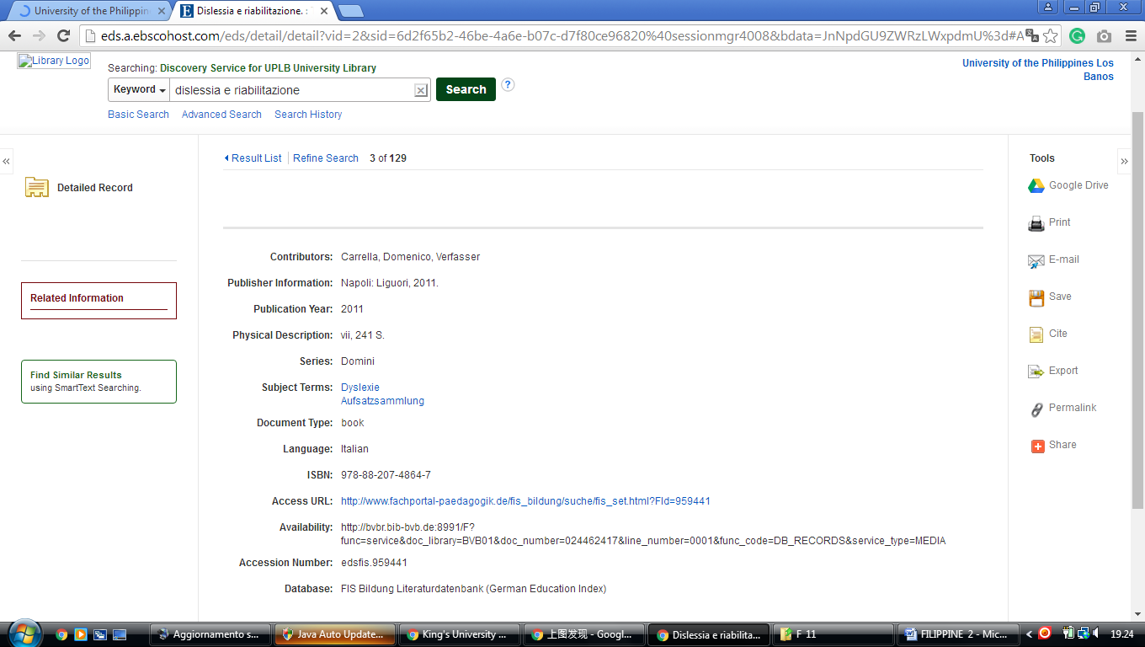

**City of Dasmariñas** [**Cavite**](https://librarytechnology.org/libraries/search.pl?City=Cavite&Country=Philippines)**,** [**Romeo P. Ariniego MD Library - Academics …**](http://www.dlshsi.edu.ph/academics/romeo-p-ariniego-md-library/) **Philippines**

[Romeo P. Ariniego MD Library - De La Salle …](http://www.dlshsi.edu.ph/academics/romeo-p-ariniego-md-library/)

[**http://www.dlshsi.edu.ph/academics/romeo-p-ariniego-md-library/**](http://www.dlshsi.edu.ph/academics/romeo-p-ariniego-md-library/)

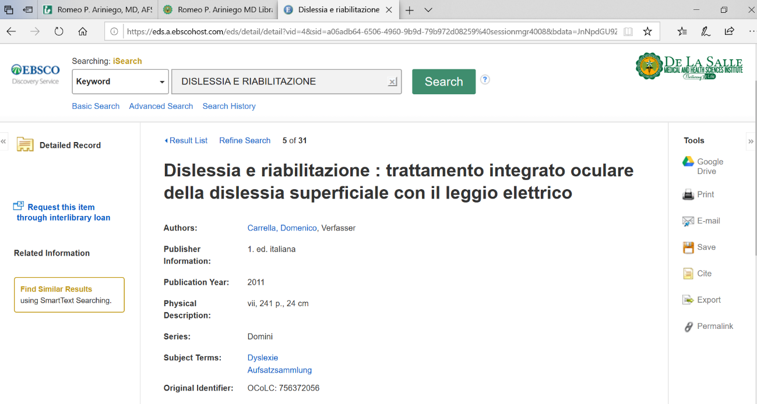

[**University Library, Diliman, University Of The FILIPPINE**](https://www.mainlib.upd.edu.ph/)

http://eds.b.ebscohost.com/eds/results?vid=3&sid=828493ec-a0a1-4853-b605-50cbd4792138%40pdc-v-sessmgr06&bquery=dislessia+e+riabilitazione&bdata=JnR5cGU9MCZzZWFyY2hNb2RlPUFuZCZzaXRlPWVkcy1saXZl

