**1 UAEU.SUMMON.SERIALSSOLUTIONS.COM – LIBRARIES DEANSHIP**

(United Arab Emirates)

<http://uaeu.summon.serialssolutions.com/search?s.q=dislessia+e+riabilitazione&spellcheck=true#!/search?ho=f&l=en&q=dislessia%20e%20riabilitazione>

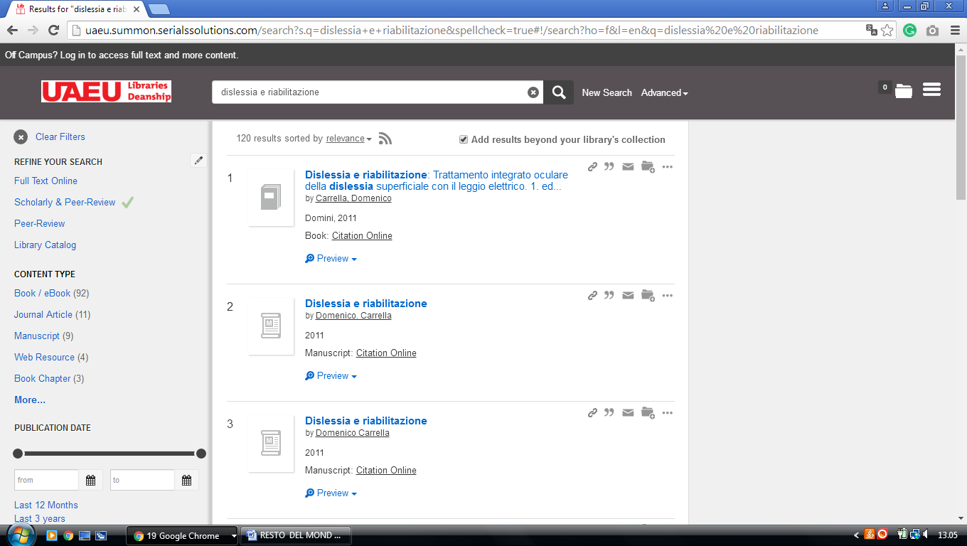

**2 SHARJAH.SUMMON.SERIALSSOLUTIONS.COM** – (Library University Of Sharjah, **United Arab Emirates)**

<http://sharjah.summon.serialssolutions.com/#!/search?ho=f&l=en&q=DISLESSIA%20E%20RIABILITAZIONE>

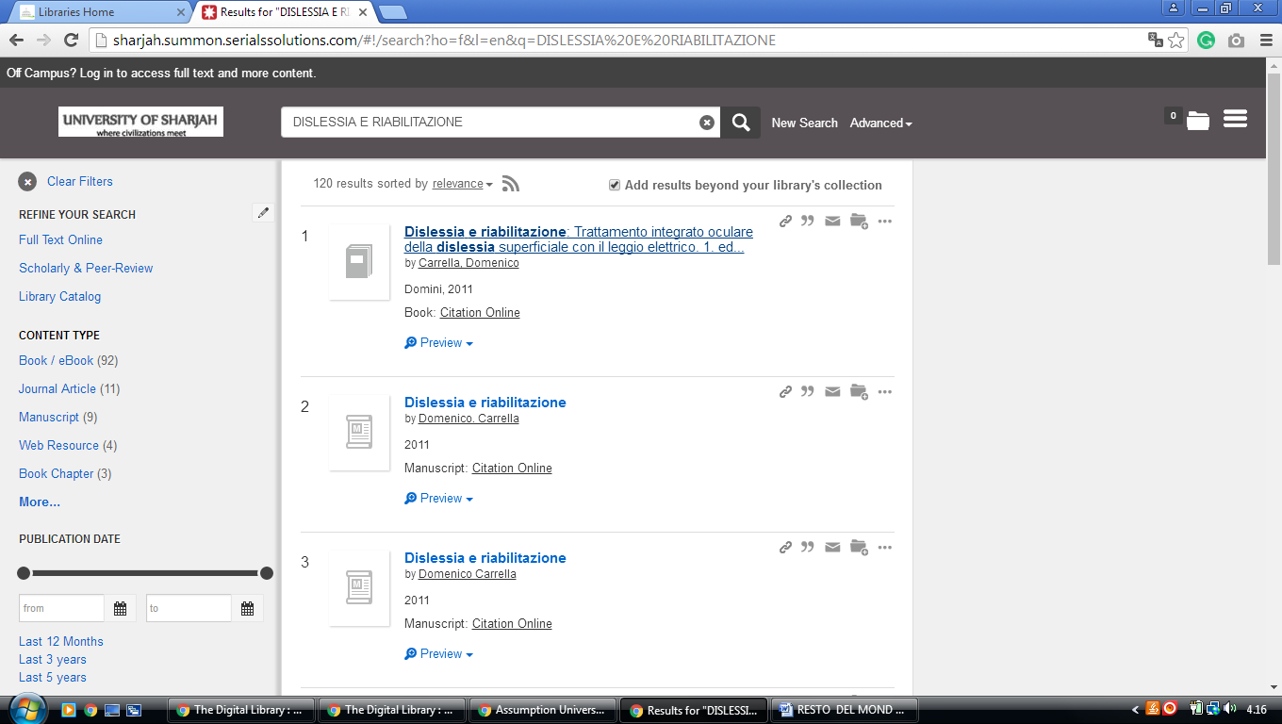

**3**  [**UNIVERSITY LIBRARY - AMERICAN UNIVERSITY OF SHARJAH**](http://library.aus.edu/)

(Sharjah - Emirati Arabi Uniti)

<https://aus.on.worldcat.org/external-search?queryString=dislessia%20e%20riabilitazione&databaseList=2375,3384,3284,3261,2328,199,3218,233,1875,2007,2006,3039,1697,3258,2268,2267,1672,2585,638,3879,2264,3374,2483,2263,2262,3197,2261,283,2260,2281,3229,1842,2513,2237,2259,3205,203,1982,3201,2277,3784,1708,3867&page=1&queryType=search&stickyFacetsChecked=false>

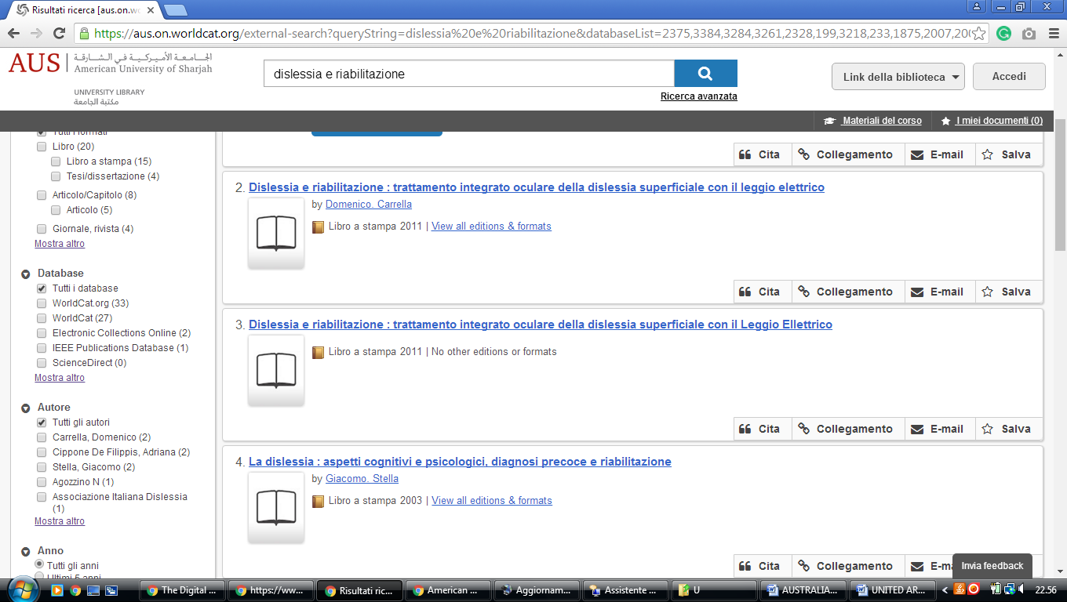

**4**  **UNIVERSITY LIBRARY - American University of Sharjah Library**

(Sharjah - Emirati Arabi Uniti)

<https://aus.on.worldcat.org/external-search?queryString=dislessia%20e%20riabilitazione&databaseList=2375,3384,3284,3261,2328,199,3218,1875,2007,233,3039,1697,2268,3258,2267,1672,2585,638,3879,2264,2263,3374,2483,2262,3197,2261,2260,283,2281,3229,2513,1842,3205,2259,2237,203,1982,3201,2277,3784,1708,3867&page=1&queryType=search&stickyFacetsChecked=false>

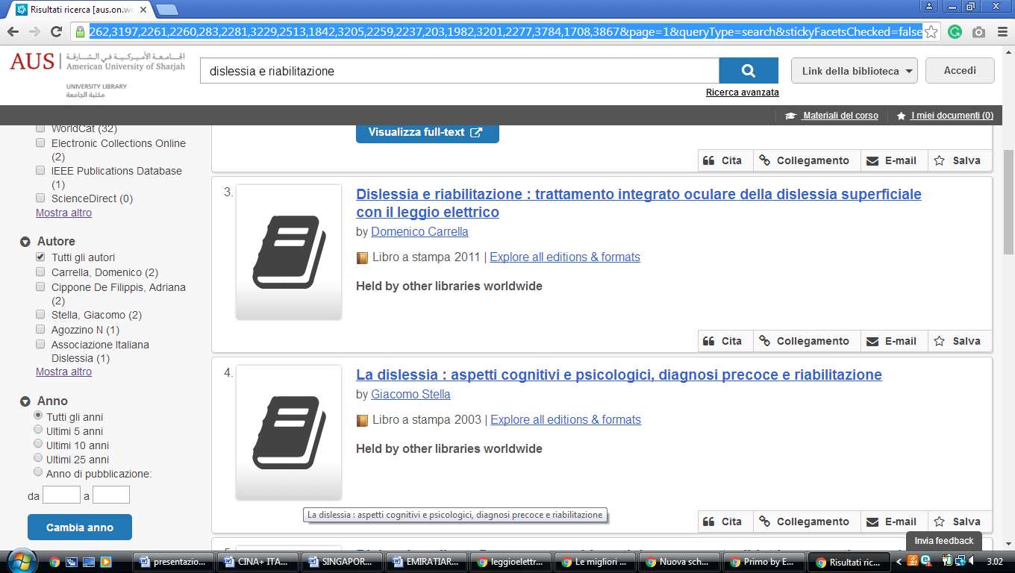

**4**  **MURDOCH UNIVERSITY in DUBAI**

(Dubai - Emirati Arabi Uniti)

[https://murdoch.summon.serialssolutions.com/#!/search?ho=f&l=en&q=dislessia%20e%20riabilitazione](https://murdoch.summon.serialssolutions.com/%23!/search?ho=f&l=en&q=dislessia%20e%20riabilitazione)

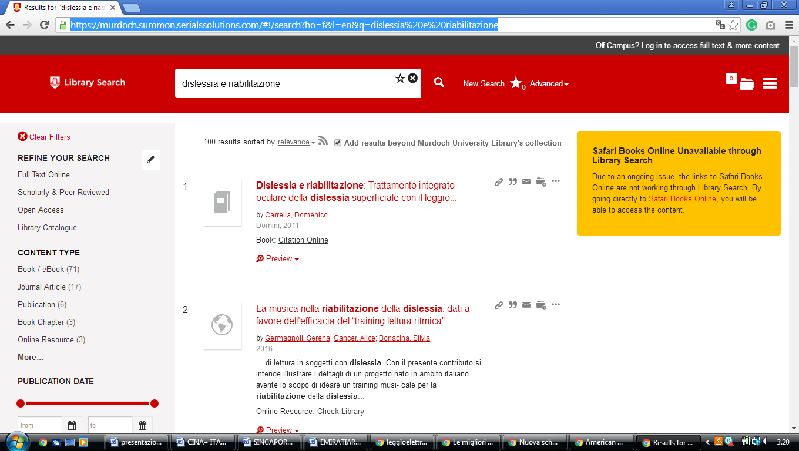

University of Dubai Library

**University of Dubai** [**Dubai**](https://librarytechnology.org/libraries/search.pl?City=Dubai&Country=United%20Arab%20Emirates),

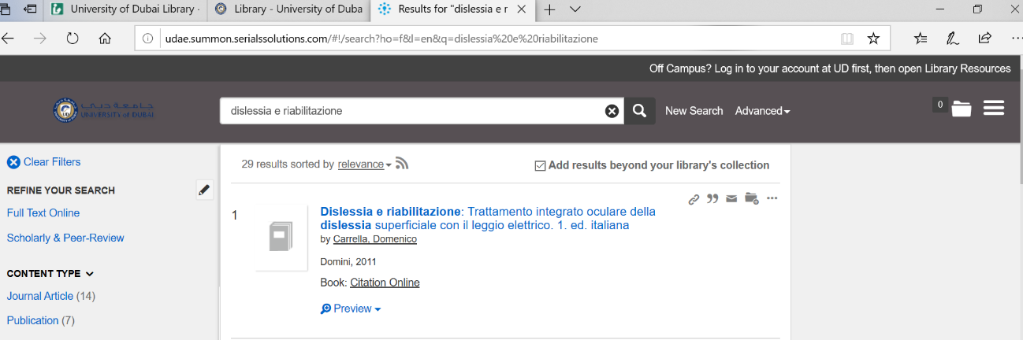udae.summon.serialssolutions.com/#!/search?ho=f&l=en&q=dislessia%20e%20riabilitazione