**INSTITUTO TECNOLÓGICO DE SANTO DOMINGO, REPUBBLICA DOMINICANA**

[Instituto Tecnológico de Santo Domingo - INTEC](https://www.google.com/url?sa=t&rct=j&q=&esrc=s&source=web&cd=2&cad=rja&uact=8&ved=2ahUKEwim7rvQp9zoAhVBcZoKHSoZBCoQFjABegQIARAC&url=https%3A%2F%2Fwww.intec.edu.do%2Fen%2F&usg=AOvVaw1F-qtf8GrV1UKYnqJpuSHT&cshid=1586468752834019)

[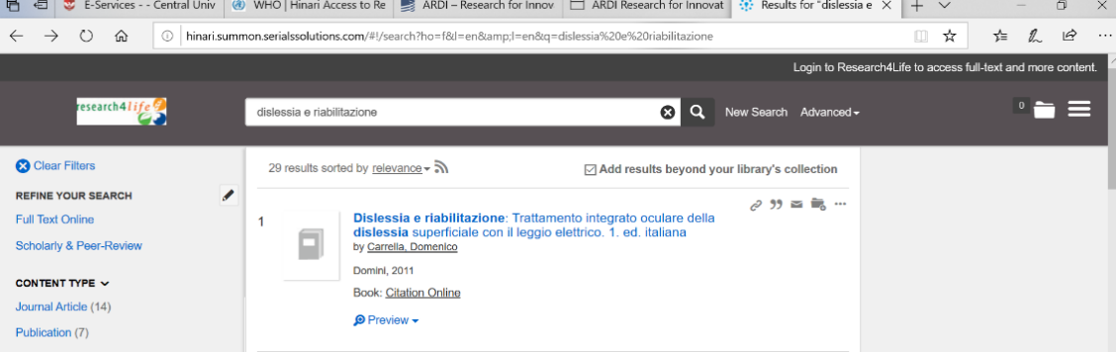](https://www.google.com/url?sa=t&rct=j&q=&esrc=s&source=web&cd=2&cad=rja&uact=8&ved=2ahUKEwim7rvQp9zoAhVBcZoKHSoZBCoQFjABegQIARAC&url=https%3A%2F%2Fwww.intec.edu.do%2Fen%2F&usg=AOvVaw1F-qtf8GrV1UKYnqJpuSHT&cshid=1586468752834019)