**25. UNIVERSITE VIRTUELLE DE COSTA D’AVORIO**

[Liens externes - Bibliotheque Virtuelle MESRS](https://www.google.com/url?sa=t&rct=j&q=&esrc=s&source=web&cd=2&cad=rja&uact=8&ved=2ahUKEwjVgoHO_IbpAhVGcZoKHVlwDrEQFjABegQIAhAB&url=https%3A%2F%2Fbibliotheque.uvci.edu.ci%2Fliens_externes&usg=AOvVaw3L1lgmLi515uTViw_TLHsN)

[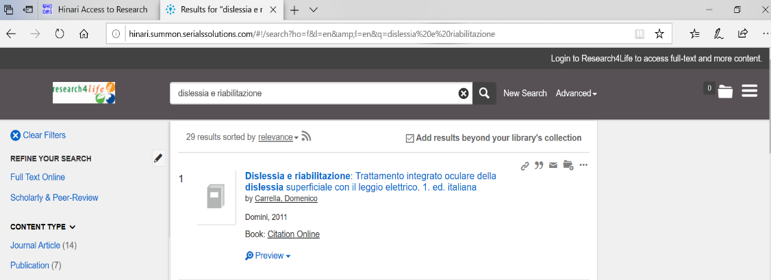](https://www.google.com/url?sa=t&rct=j&q=&esrc=s&source=web&cd=2&cad=rja&uact=8&ved=2ahUKEwjVgoHO_IbpAhVGcZoKHVlwDrEQFjABegQIAhAB&url=https%3A%2F%2Fbibliotheque.uvci.edu.ci%2Fliens_externes&usg=AOvVaw3L1lgmLi515uTViw_TLHsN)