### 1 [SISTEMA DE BIBLIOTECAS - ESPAÑOL - UNIVERSIDAD DE LOS ANDES](https://biblioteca.uniandes.edu.co/)

**(**Bogotá, Colombia)

<https://univdelosandes.on.worldcat.org/search?sortKey=LIBRARY&databaseList=&queryString=kw%3ADISLESSIA+E+RIABILITAZIONE&changedFacet=scope&scope=&scope=wz%3A34246&format=all&database=all&author=all&year=all&yearFrom=&yearTo=#/oclc/941217209>

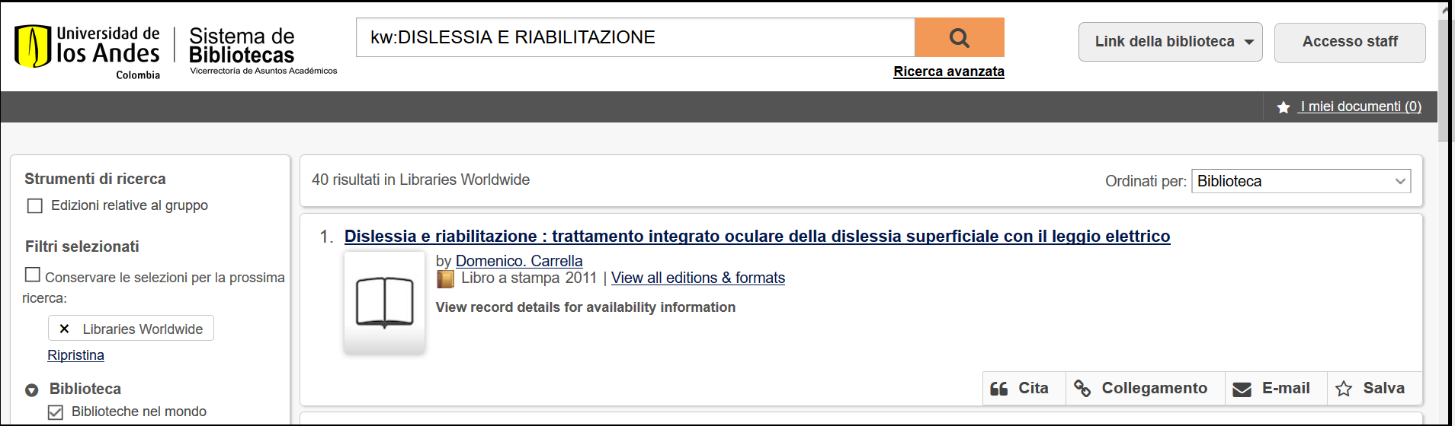

**2 U**[**NIVERSIDAD DEL VALLE DIVISION DE BIBLIOTECAS –** (](http://biblioteca.univalle.edu.co/)Colombia)

<http://eds.b.ebscohost.com/eds/detail/detail?vid=1&sid=dbc04007-20ae-44c6-a1c5-22dd4585cfd6%40sessionmgr120&bdata=Jmxhbmc9ZXMmc2l0ZT1lZHMtbGl2ZQ%3d%3d#AN=EDSBVB.BV039611798&db=edsbvb>

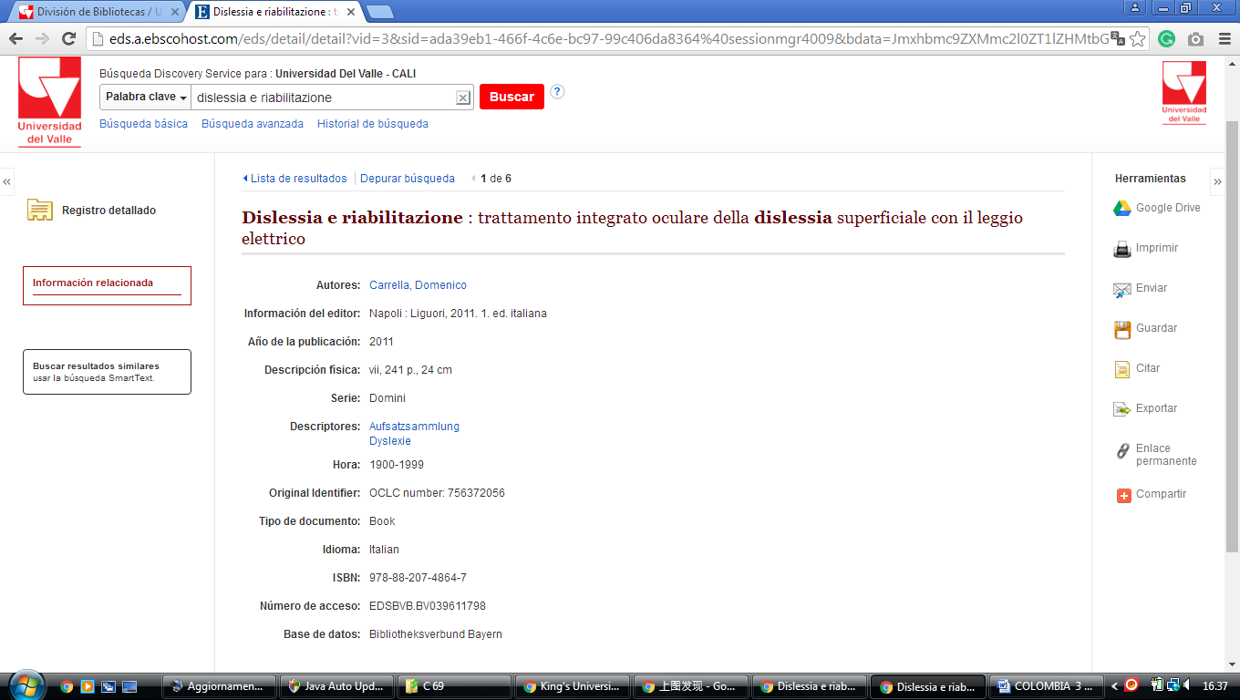

### 3 [BIBLIOTECA UNIMINUTO](http://biblioteca.uniminuto.edu/) De DIOS -  ([Bogotà, Colombia](https://www.google.it/search?rlz=1C1CHIK_itIT460IT464&q=Bogot%C3%A1+Colombia&stick=H4sIAAAAAAAAAOPgE-LWT9c3NDJKrsoqT1bi1M_VNzBMqapM1lLNTrbSzy9KT8zLrEosyczPQ-FYpeWX5qWkpgAAkTBXrEEAAAA&sa=X&ved=0ahUKEwim1sackuzZAhXCXiwKHdOJBz0QmxMIxQEoATAR))

### [http://uniminuto.summon.serialssolutions.com/search?fn=go&vl%28182972193UI1%29=all_items&s.q=dislessia+&ct=search&indx=0&dum=true#!/search?ho=f&l=es-ES&q=dislessia%20e%20riabilitazione](http://uniminuto.summon.serialssolutions.com/search?fn=go&vl%28182972193UI1%29=all_items&s.q=dislessia+&ct=search&indx=0&dum=true%23!/search?ho=f&l=es-ES&q=dislessia%20e%20riabilitazione)

### 

### 4 [CENTRO BIBLIOTECA JORGE ROA MARTÍNEZ](https://biblioteca.utp.edu.co/) - (Colombia)

<https://utp.on.worldcat.org/search?queryString=kw%3Adislessia+e+riabilitazione&subformat>=

