1 Baidu ([百](https://it.wiktionary.org/wiki/%E7%99%BE)[度](https://it.wiktionary.org/wiki/%E5%BA%A6)=Bǎidù) - (Il Più Grande Motore Di Ricerca Cinese)

<http://xueshu.baidu.com/s?wd=paperuri:(0b9870f01c53503cee8ceb15bc57551f)&filter=sc_long_sign&sc_ks_para=q%3DDislessia+e+riabilitazione+%3A+trattamento+integrato+oculare+della+dislessia+superficiale+con+il+Leggio+Ellettrico&tn=SE_baiduxueshu_c1gjeupa&ie=utf-8&sc_us=641842458683849525>

**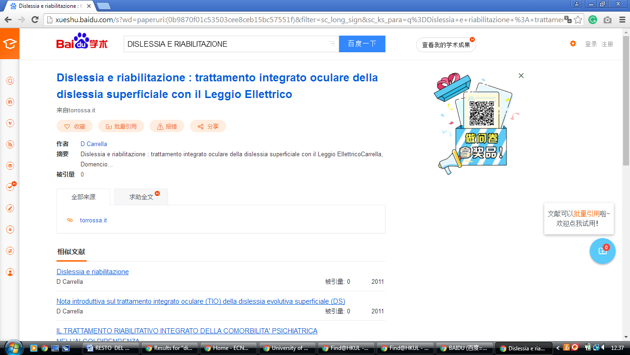**

### 2 Lib.Shisu.Edu.Cn – ([Shanghai International Studies University Library](http://lib.shisu.edu.cn/en/index.aspx)  [China](https://en.wikipedia.org/wiki/China))

<http://s.lib.shisu.edu.cn/primo_library/libweb/action/dlSearch.do?institution=SHISU&vid=shisu&search_scope=default_scope&onCampus=false&group=GUEST&prefLang=en_US&query=any,contains,dislessia%20e%20riabilitazione&pcAvailabiltyMode=true&bulkSize=20>

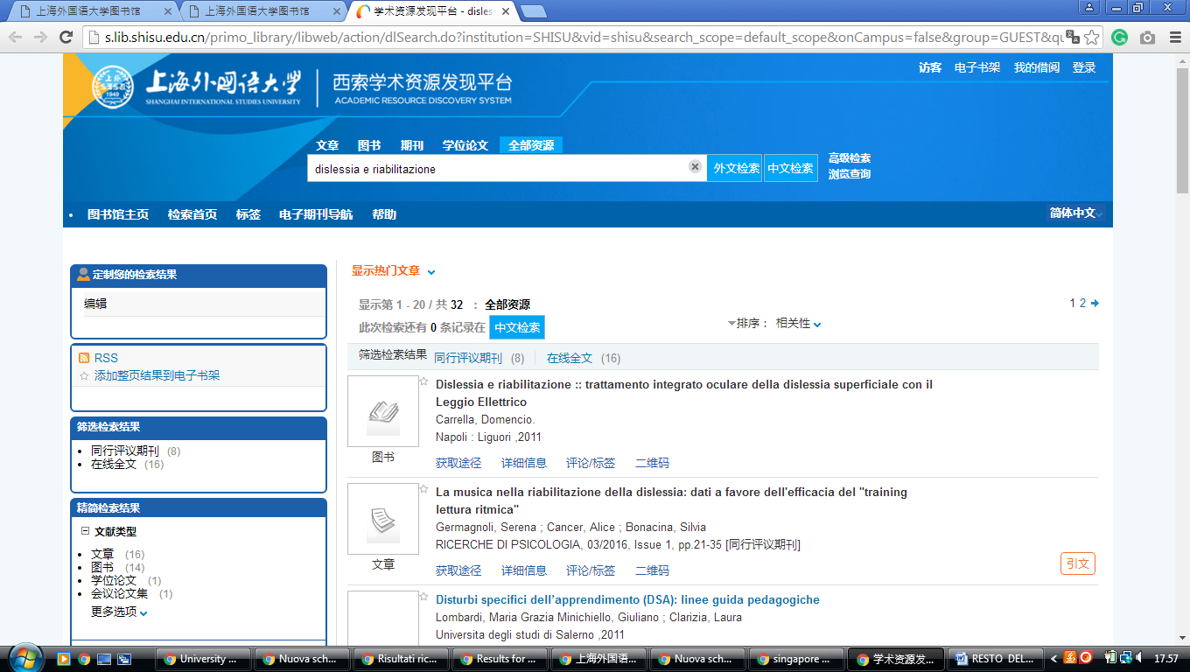

### 3 The Library - Peking University Library – (China)

<http://pku.summon.serialssolutions.com/en/search?s.q=DISLESSIA++E+RIABILITAZIONE#!/search?ho=f&l=en&q=DISLESSIA%20%20E%20RIABILITAZIONE>

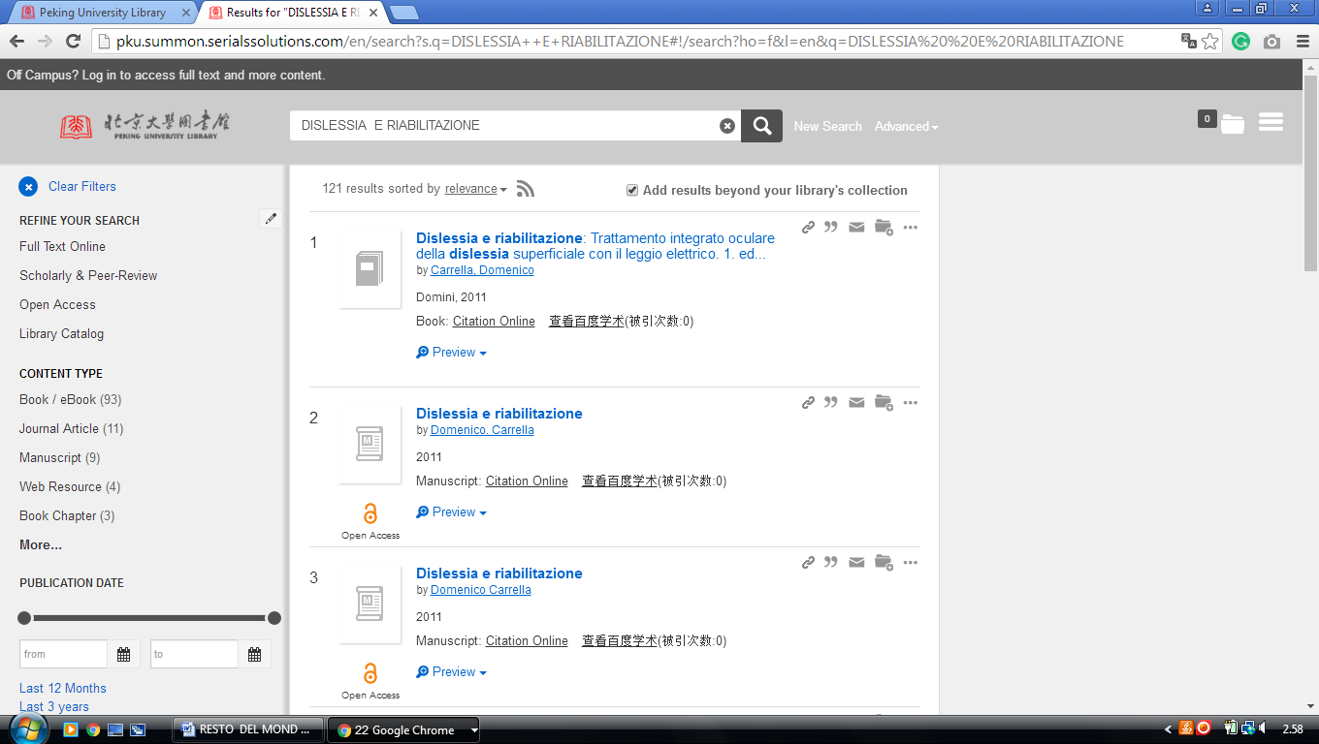

http://pku.summon.serialssolutions.com/search?s.q=dislessia+e+riabilitazione#!/search?ho=f&l=zh-CN&q=dislessia%20e%20riabilitazione

-------------------------------------------------------------------------------------------------------------------------------

4 [En.Shl.Findplus.Cn](http://en.shl.findplus.cn) – ([Library](http://www.library.sh.cn/) Shanghai, China)

[http://en.shl.findplus.cn/?h=search\_list&query=DISLESSIA%20E%20RIABILITAZIONE&action[addexpander][]=fulltext](http://en.shl.findplus.cn/?h=search_list&query=DISLESSIA%20E%20RIABILITAZIONE&action%5baddexpander%5d%5b%5d=fulltext)

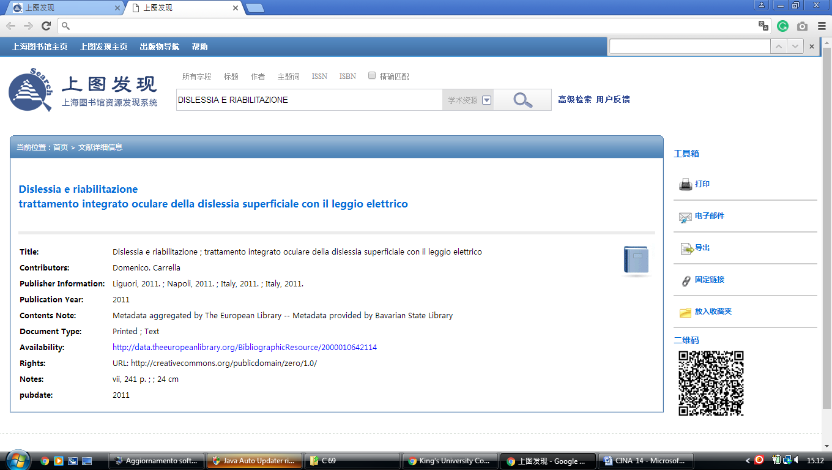

5 Library [Zhejiang University](http://libweb.zju.edu.cn/libweb/) – (Hangzhou, China)

<http://zju.summon.serialssolutions.com/en/search?s.q=dislessia+e+riabilitazione&search_options=on#!/search?ho=f&l=en&q=dislessia%20e%20riabilitazione>

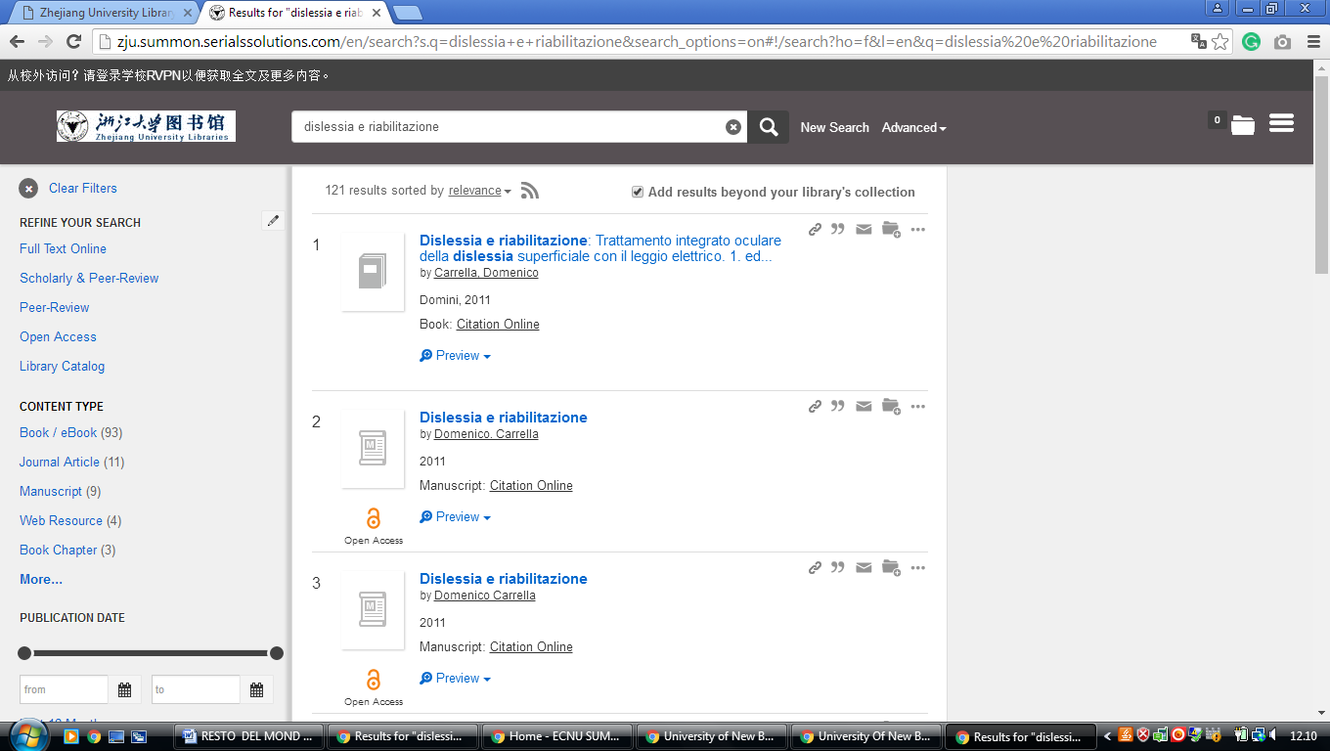

6 [China University Of Geosciences](http://www.lib.cug.edu.cn/" \t "_blank" \o "China University Of Geosciences) Library – (Wuhan, China)

<http://cug.summon.serialssolutions.com/search?but1=&q=dislessia+e+riabilitazione#!/search?ho=f&l=en&q=dislessia%20e%20riabilitazione>

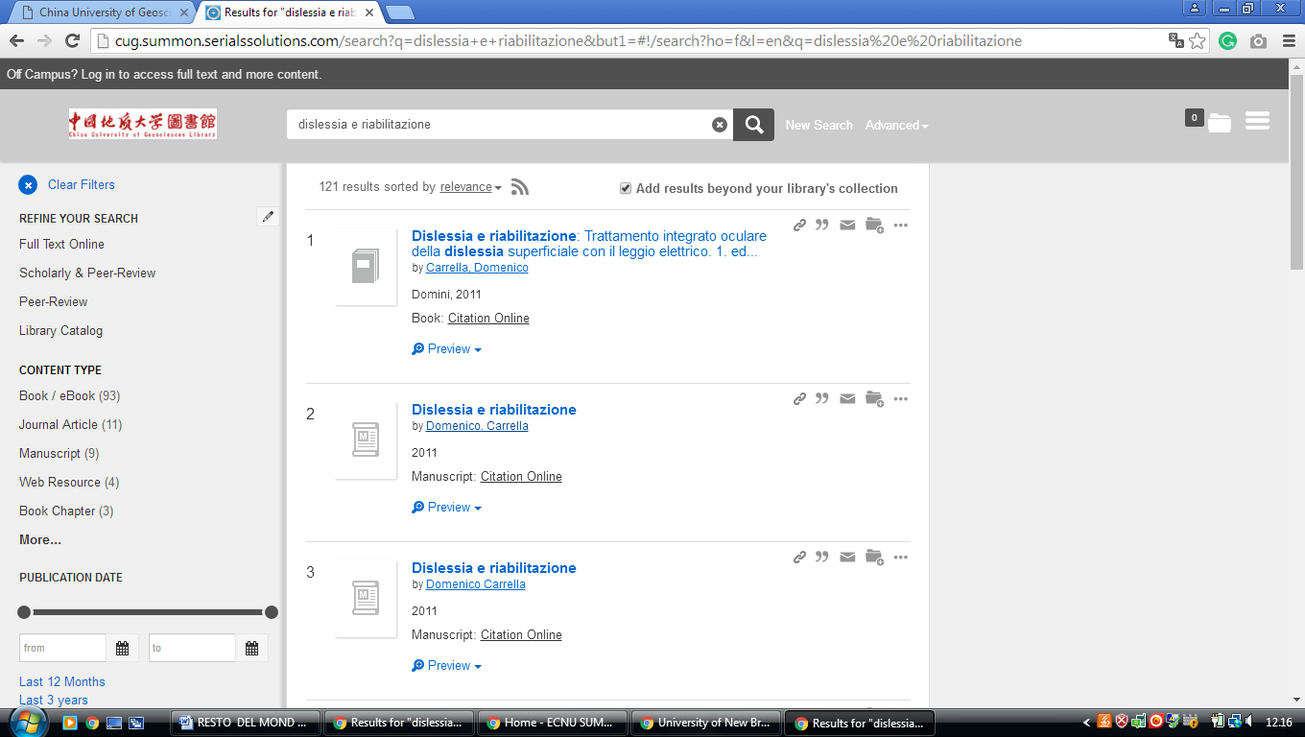

[7 National Chengchi University Library](http://www.lib.nccu.edu.tw/?lan=en) – ([Taipei](https://en.wikipedia.org/wiki/Taipei), [Republic Of China](https://en.wikipedia.org/wiki/Republic_of_China))

<http://primo2.lib.nccu.edu.tw/primo_library/libweb/action/search.do;jsessionid=797CF83A842266EA7D228F0CACACA49C?vl(freeText0)=dislessia%20e%20riabilitazione&dscnt=0&tab=default&mode=Basic&vid=NCCU&fn=search&backFromPreferences=true>

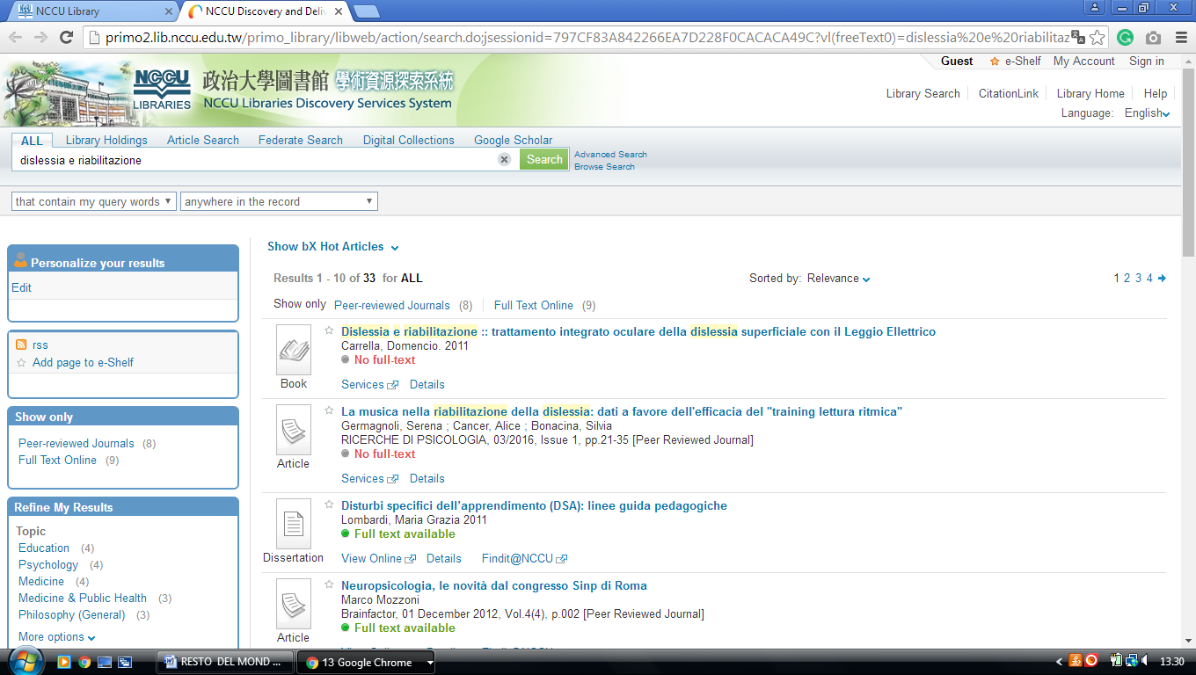

8 [Chang Jung Christian University Library](http://eservice.lib.cjcu.edu.tw/site/) - ([Guiren](https://en.wikipedia.org/wiki/Guiren_District" \o "Guiren District),[Tainan](https://en.wikipedia.org/wiki/Tainan),[Taiwan](https://en.wikipedia.org/wiki/Taiwan) China)

<http://discovery.lib.cjcu.edu.tw/primo_library/libweb/action/search.do?ct=facet&pcAvailabiltyMode=true&dscnt=0&dum=true&indx=1&frbg=&tab=ils_pc&dstmp=1518079492258&srt=rank&vl(freeText0)=dislessia%20e%20riabilitazione&vid=CJCU&fn=search&mode=Basic>

**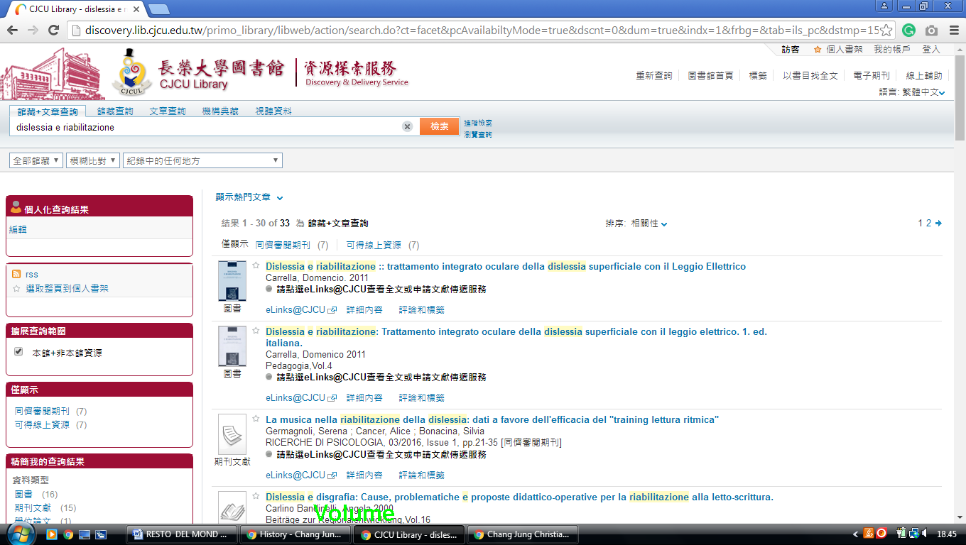**

### 9 [Shanghai International Studies University Library - 上海外国语大学](http://lib.shisu.edu.cn/en/index.aspx), - China

<http://s.lib.shisu.edu.cn/primo_library/libweb/action/dlSearch.do?institution=SHISU&vid=shisu&search_scope=default_scope&onCampus=false&group=GUEST&prefLang=en_US&query=any,contains,dislessia%20e%20riabilitazione&pcAvailabiltyMode=true&bulkSize=20>

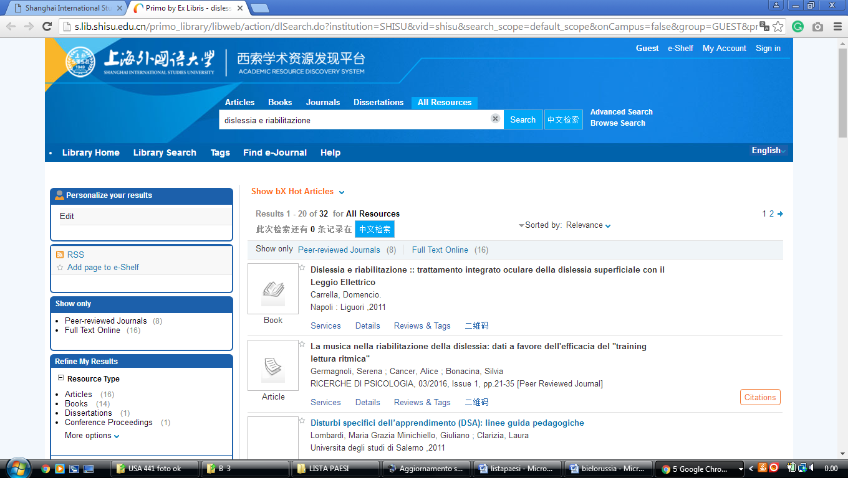

10 Tsinghua University Library - China

<https://tsinghua-primo.hosted.exlibrisgroup.com/primo-explore/search?query=any,contains,dislessia%20e%20riabilitazione&tab=default_tab&search_scope=default_scope&vid=86THU&lang=en_US&offset=0&sortby=rank&pcAvailability=true>

[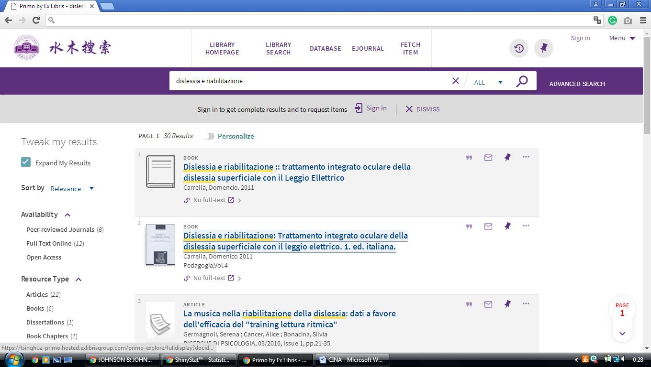](https://tsinghua-primo.hosted.exlibrisgroup.com/primo-explore/search?query=any,contains,dislessia%20e%20riabilitazione&tab=default_tab&search_scope=default_scope&vid=86THU&lang=en_US&offset=0&sortby=rank&pcAvailability=true)

11 Http://En.Cmu.Findplus.Cn

[http://en.cmu.findplus.cn/?h=search\_list&query=dislessia+e+riabilitazione&action[addexpander][]=fulltext](http://en.cmu.findplus.cn/?h=search_list&query=dislessia+e+riabilitazione&action%5baddexpander%5d%5b%5d=fulltext)

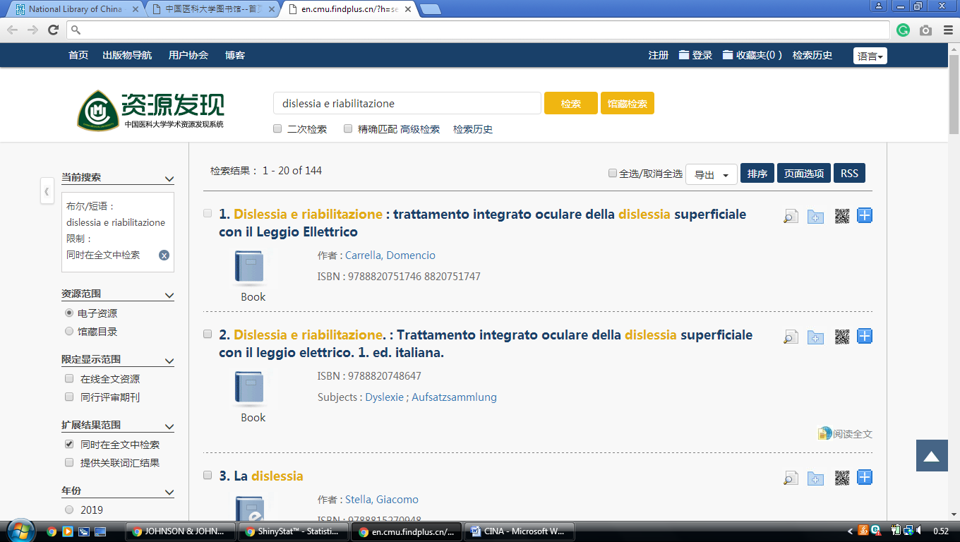

12 Northeast Forestry University Library

[http://nefu.summon.serialssolutions.com/search?s.q=dislessia+e+riabilitazione#!/search?ho=f&l=zh-CN&q=dislessia%20e%20riabilitazione](http://nefu.summon.serialssolutions.com/search?s.q=dislessia+e+riabilitazione%23!/search?ho=f&l=zh-CN&q=dislessia%20e%20riabilitazione)

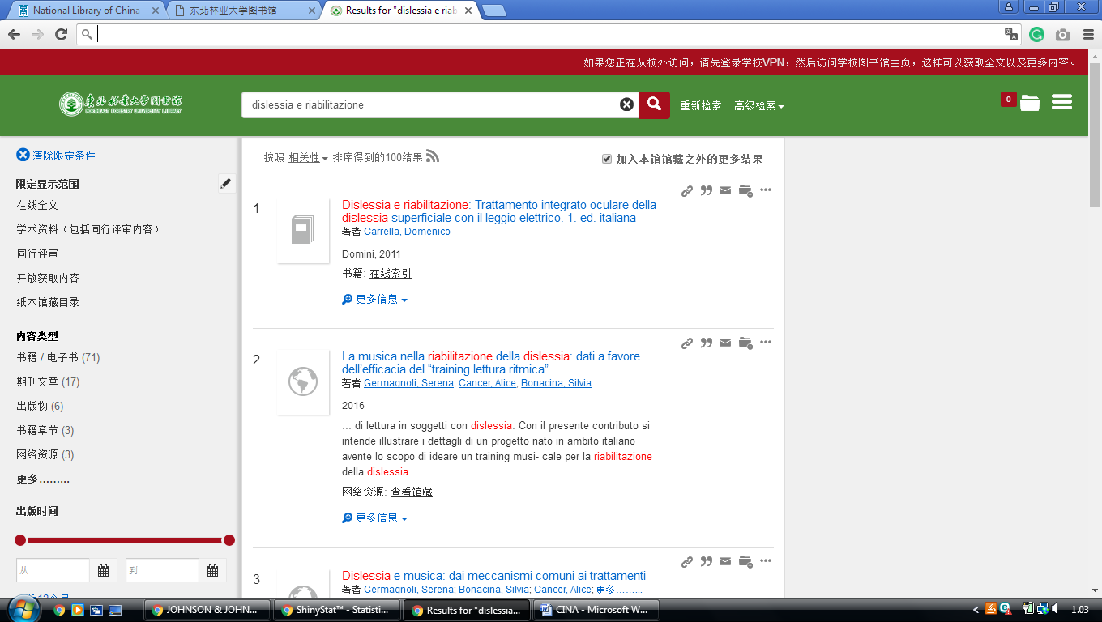



13 Fudan University Library Resource Discovery Sistem

<http://discovery.fudan.edu.cn/primo_library/libweb/action/search.do?fn=search&ct=search&initialSearch=true&mode=Basic&tab=digital_tab&indx=1&dum=true&srt=rank&vid=fdu&frbg=&tb=t&vl%28freeText0%29=++DISLESSIA+E+RIABILITAZIONE&scp.scps=ZhiZhenArticle%2Cprimo_central_multiple_fe>

[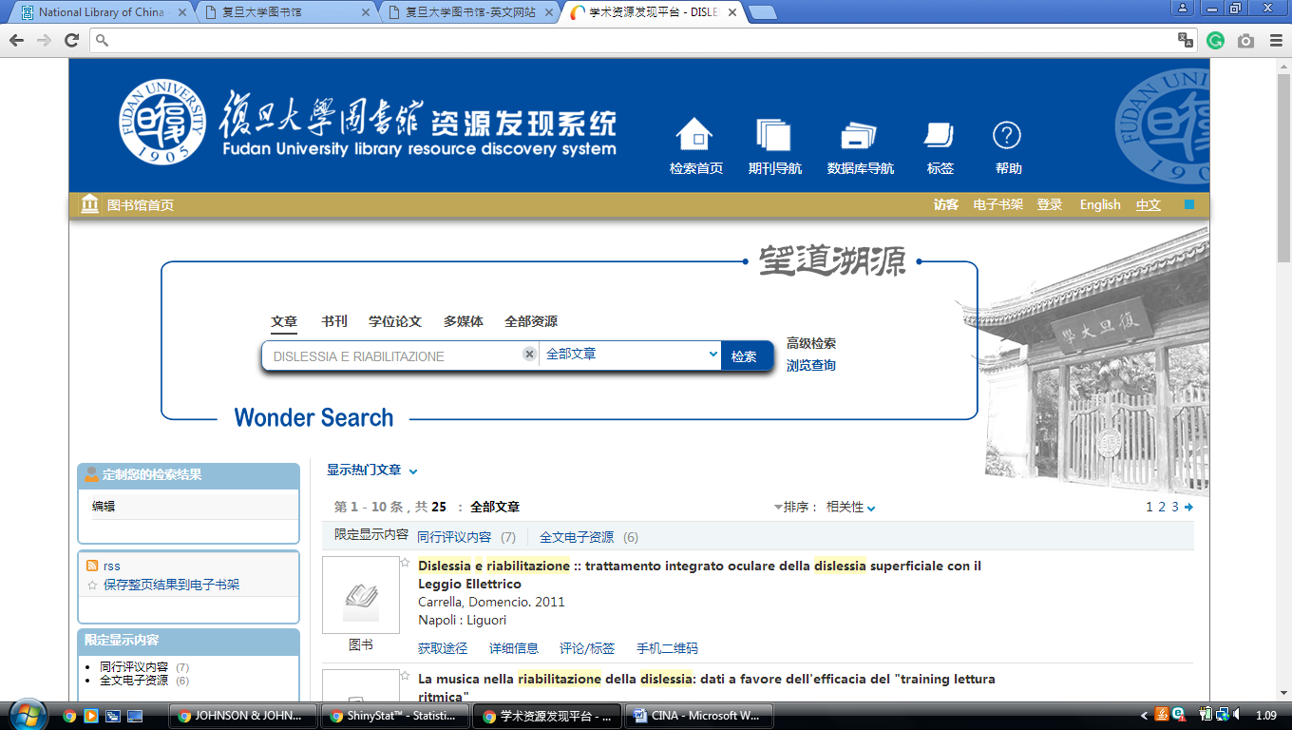](http://discovery.fudan.edu.cn/primo_library/libweb/action/search.do?fn=search&ct=search&initialSearch=true&mode=Basic&tab=digital_tab&indx=1&dum=true&srt=rank&vid=fdu&frbg=&tb=t&vl%28freeText0%29=++DISLESSIA+E+RIABILITAZIONE&scp.scps=ZhiZhenArticle%2Cprimo_central_multiple_fe)

14 South China University Of Tecnology

[http://scut.summon.serialssolutions.com/search?s.q=dislessia+e+riabilitazione#!/search?ho=f&l=zh-CN&q=dislessia%20e%20riabilitazione](http://scut.summon.serialssolutions.com/search?s.q=dislessia+e+riabilitazione%23!/search?ho=f&l=zh-CN&q=dislessia%20e%20riabilitazione)

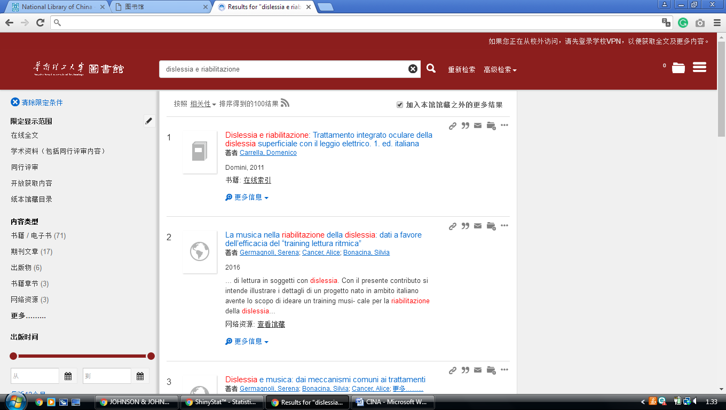

15 China Università Of Geosciences Library

<http://cug.summon.serialssolutions.com/search?pn=1&ho=t&l=za&q=dislessia+e+riabilitazione#!/search?ho=f&l=za&q=dislessia%20e%20riabilitazione>

**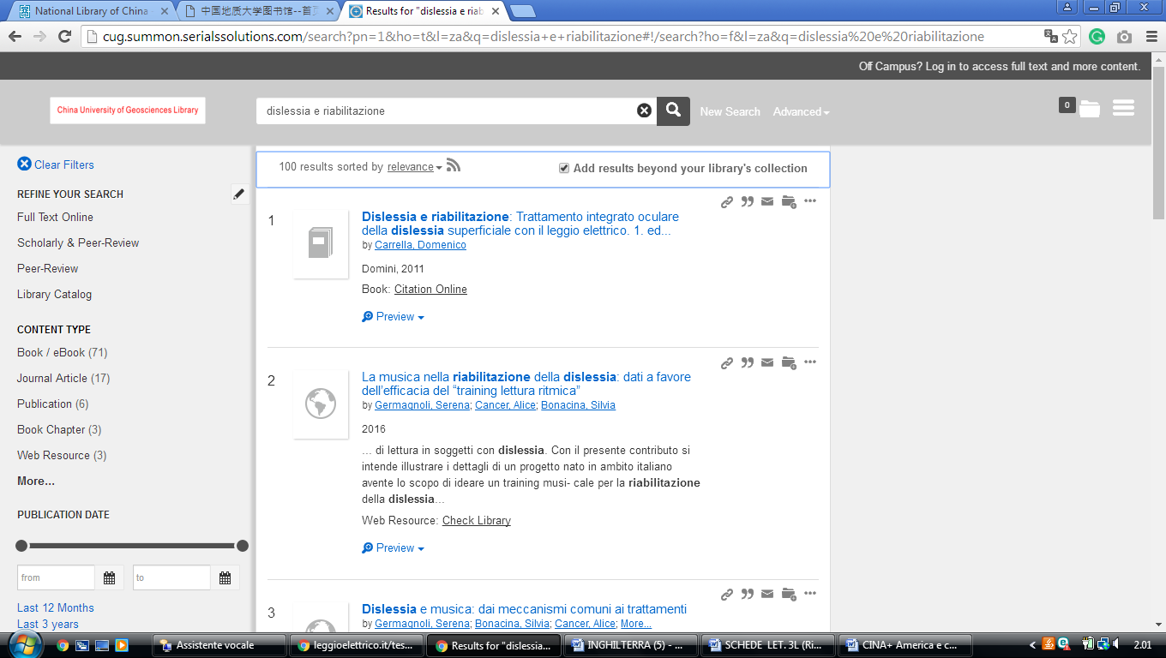**

16 [Sichuan University Library](http://lib.scu.edu.cn/)

<http://discovery.scu.edu.cn/primo-explore/search?query=any,contains,dislessia%20e%20riabilitazione&tab=all_tab&search_scope=all_resource&sortby=rank&vid=scu2&lang=zh_CN&offset=0>

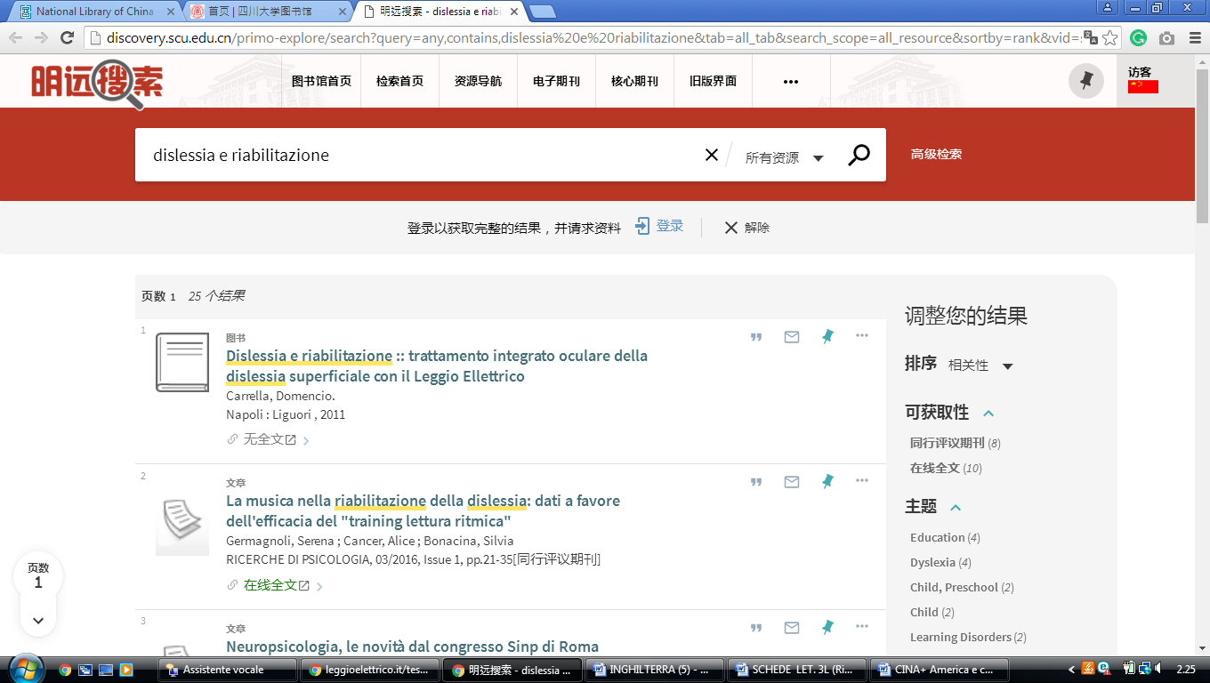

17 [Library Of China University Of Geosciences](http://www.lib.cug.edu.cn/)

[http://cug.summon.serialssolutions.com/search?pn=1&ho=t&l=za&q=dislessia+e+riabilitazione#!/search?ho=f&l=za&q=dislessia%20e%20riabilitazione](http://cug.summon.serialssolutions.com/search?pn=1&ho=t&l=za&q=dislessia+e+riabilitazione%23!/search?ho=f&l=za&q=dislessia%20e%20riabilitazione)

**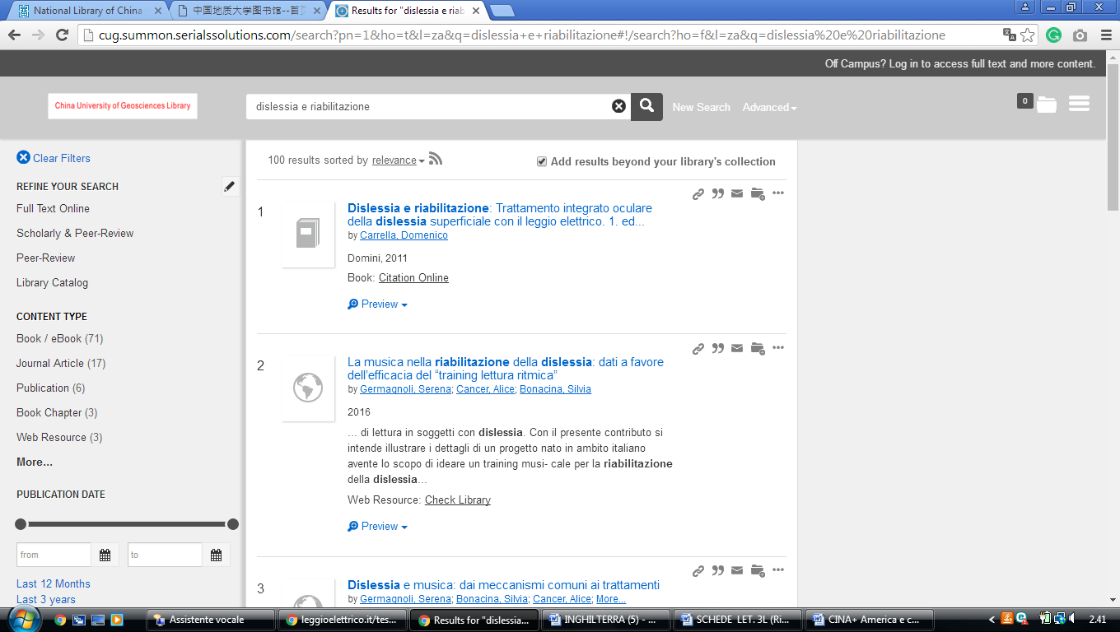**

18 [Tongji University Library](http://www.lib.tongji.edu.cn/)

<http://tongji.summon.serialssolutions.com/zh-CN/search?s.q=dislessia%20e%20riabilitazione#!/search?ho=f&l=zh-CN&q=dislessia%20e%20riabilitazione>

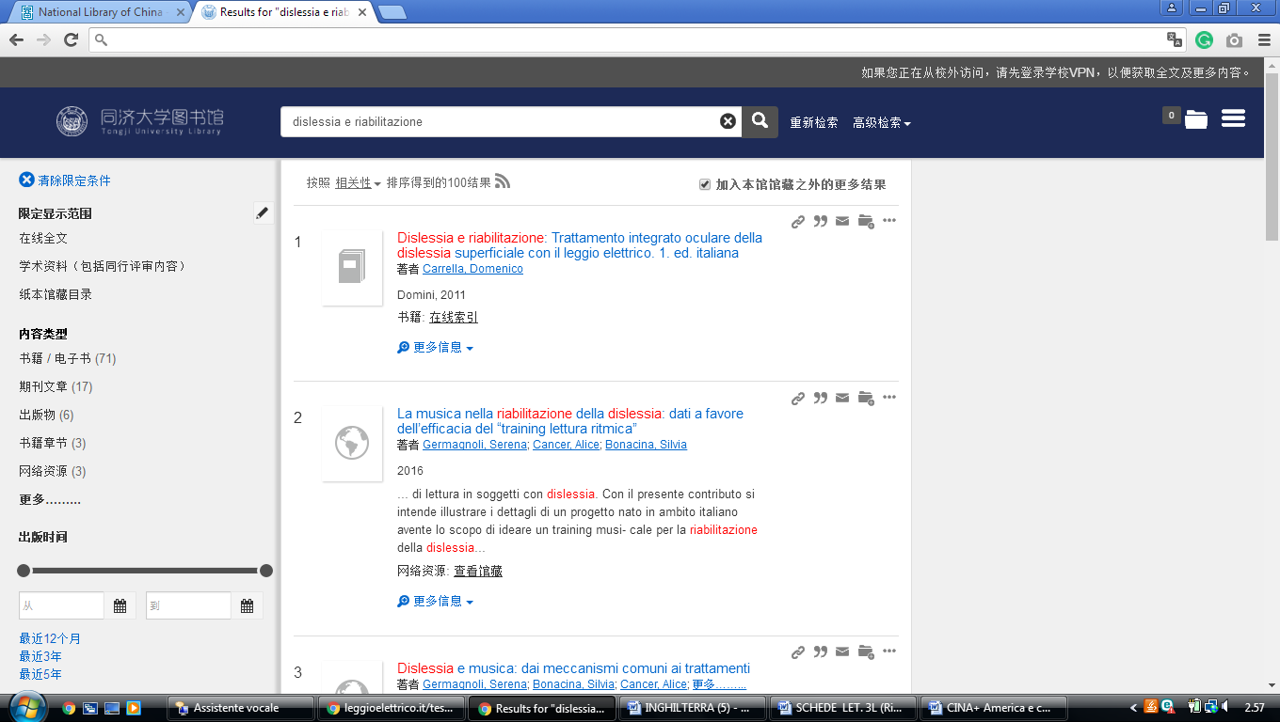

19 [Soochow University Library](http://library.suda.edu.cn/englishweb/index.htm)

<http://suda.summon.serialssolutions.com/search?s.q=dislessia%20e%20riabilitazione#!/search?ho=f&l=zh-CN&q=dislessia%20e%20riabilitazione>

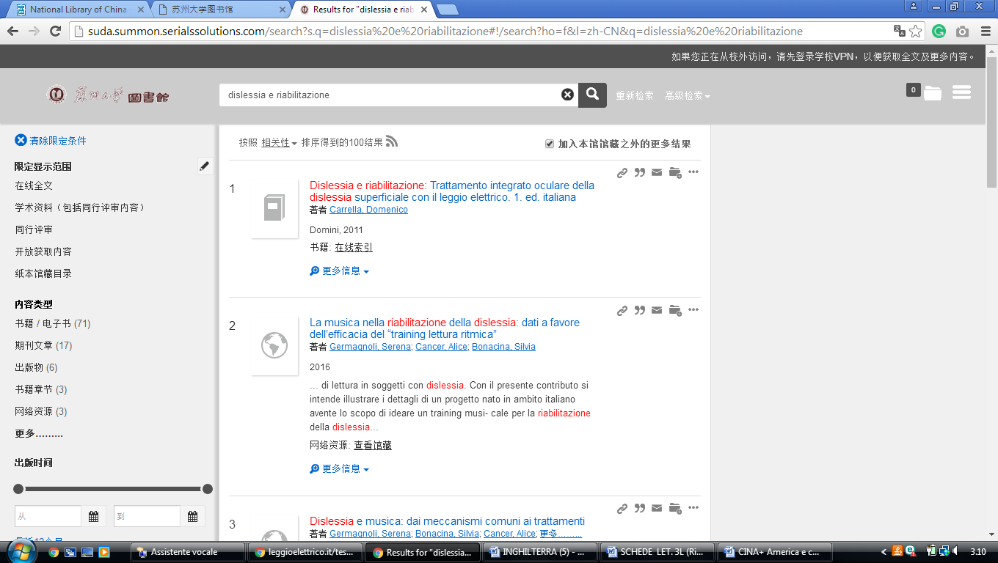

20 [Shandong University Library](http://www.lib.sdu.edu.cn/)

<https://sducn.summon.serialssolutions.com/#!/search?ho=f&l=zh-CN&q=dislessia%20e%20riabilitazione>

**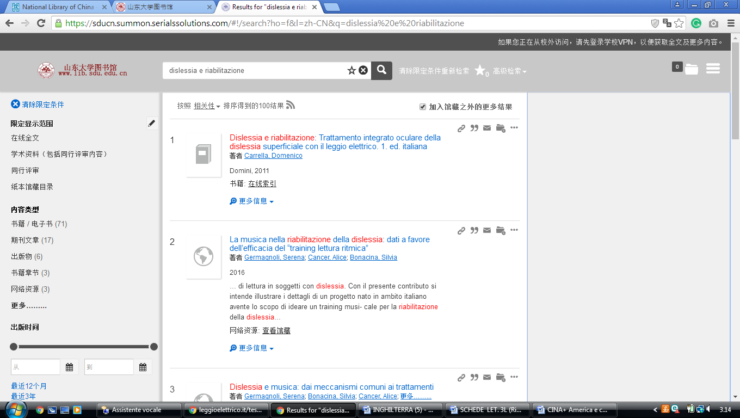**

21 [The Library of Shandong Normal University](http://www.elib.sdnu.edu.cn/)

<https://sdnu.summon.serialssolutions.com/search?s.q=dislessia+e+riabilitazione#!/search?ho=f&l=zh-CN&q=dislessia%20e%20riabilitazione>

**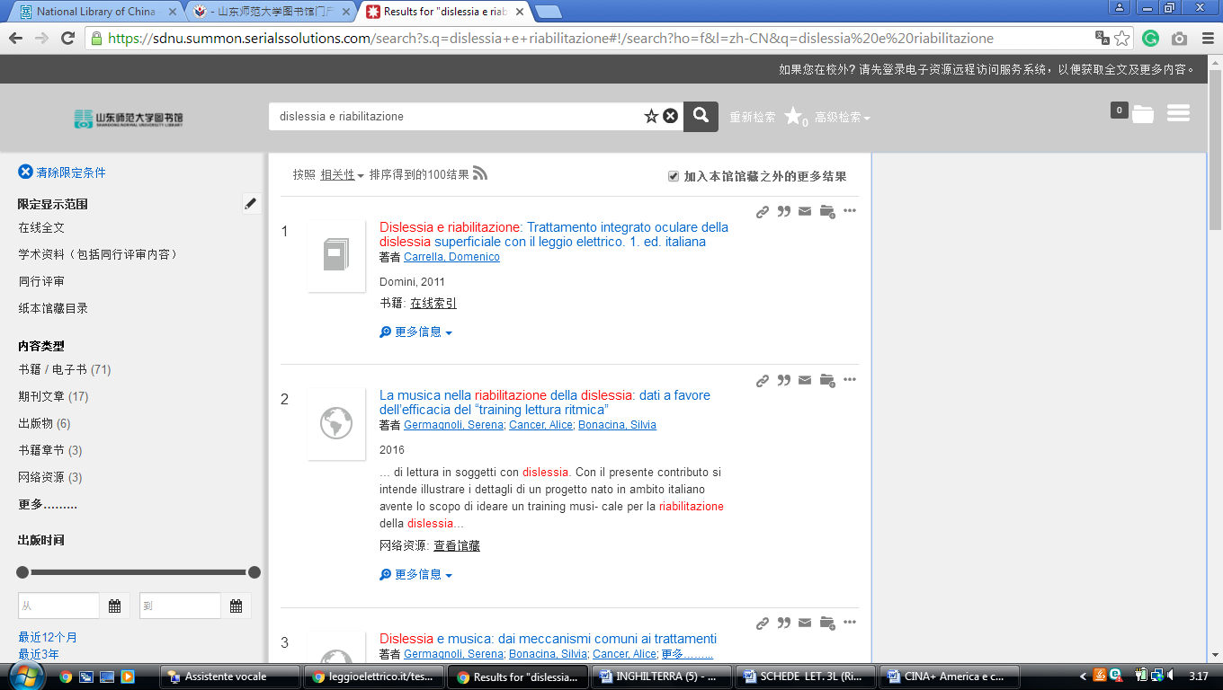**

22 [Huazhong Agricultural University Library](http://lib.hzau.edu.cn/)

<http://eds.b.ebscohost.com/eds/results?vid=0&sid=07d9226a-590c-440e-804c-beb196e01e76%40pdc-v-sessmgr01&bquery=dislessia%2Be%2Briabilitazione&bdata=Jmxhbmc9emgtY24mdHlwZT0wJnNlYXJjaE1vZGU9QW5kJnNpdGU9ZWRzLWxpdmU%3d>

**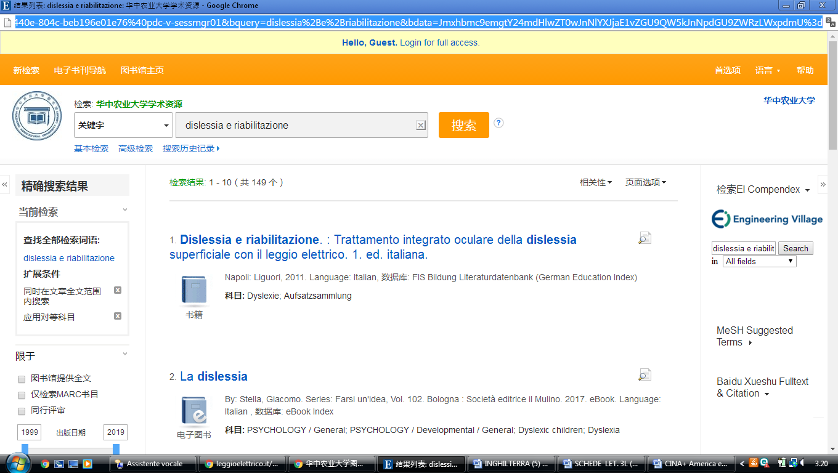**

23 [Lanzhou University Library](http://lib.lzu.edu.cn/)

<http://lzu.summon.serialssolutions.com/search?s.q=dislessia+e+riabilitazione#!/search?ho=f&l=zh-CN&q=dislessia%20e%20riabilitazione>

**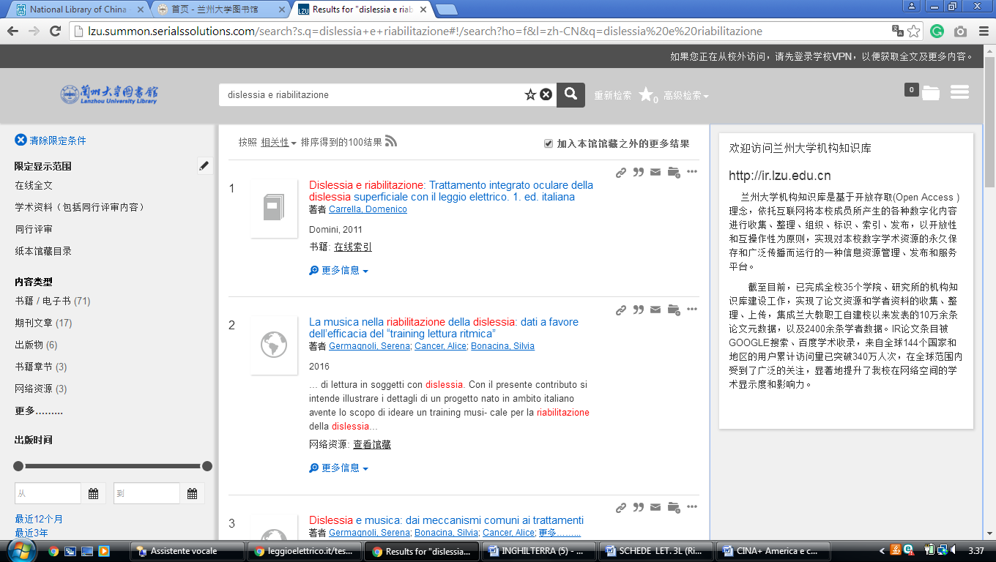**

24 [Sichuan Normal University Library](http://www.lib.sicnu.edu.cn/)

[http://sicnu.summon.serialssolutions.com/search?s.q=dislessia+e+riabilitazione#!/search?ho=f&l=en&q=dislessia%20e%20riabilitazione](http://sicnu.summon.serialssolutions.com/search?s.q=dislessia+e+riabilitazione%23!/search?ho=f&l=en&q=dislessia%20e%20riabilitazione)

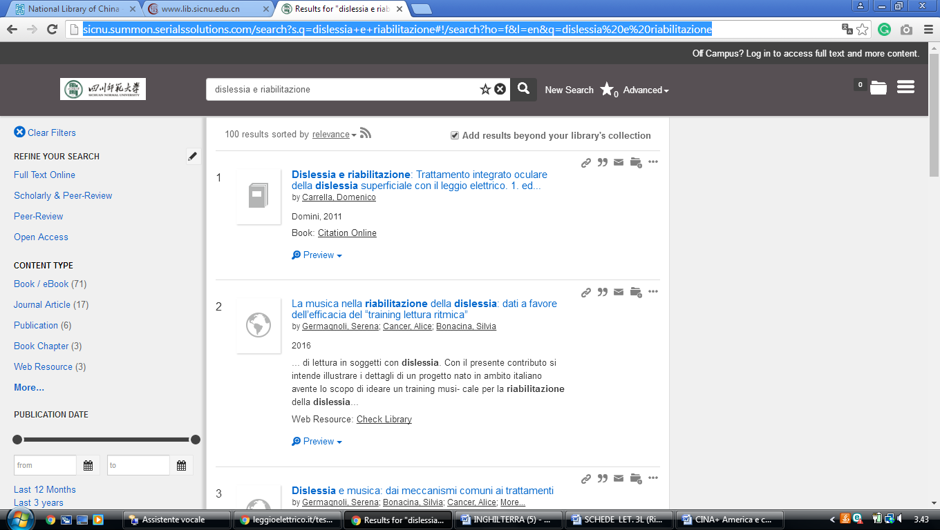

25 [Heilongjiang University Library](http://210.46.107.20/)

[http://china-3.summon.serialssolutions.com/search?ho=t&l=en&q=dislessia+e+riabilitazione#!/search?ho=f&l=en&q=dislessia%20e%20riabilitazione](http://china-3.summon.serialssolutions.com/search?ho=t&l=en&q=dislessia+e+riabilitazione%23!/search?ho=f&l=en&q=dislessia%20e%20riabilitazione)

**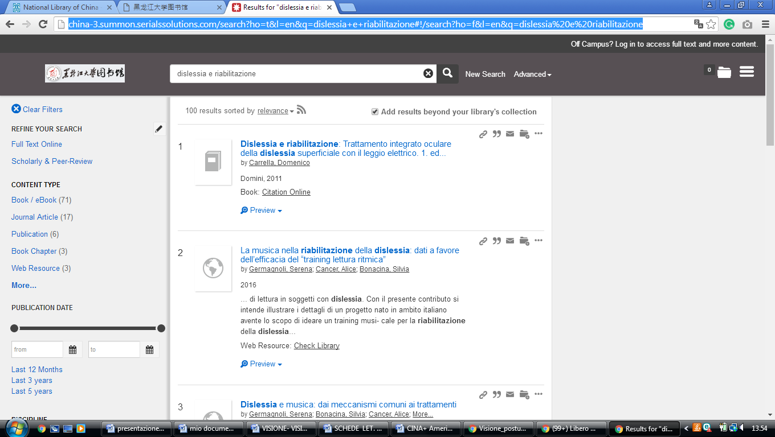**

26 [Harbin Institute of Technology Library](http://www.lib.hit.edu.cn/)

<http://eds.b.ebscohost.com/eds/results?vid=0&sid=e49051ea-3cae-45c8-91fc-2dd2bc1e9b66%40sessionmgr102&bquery=dislessia%2Be%2Briabilitazione&bdata=Jmxhbmc9emgtY24mdHlwZT0wJnNlYXJjaE1vZGU9QW5kJnNpdGU9ZWRzLWxpdmU%3d>

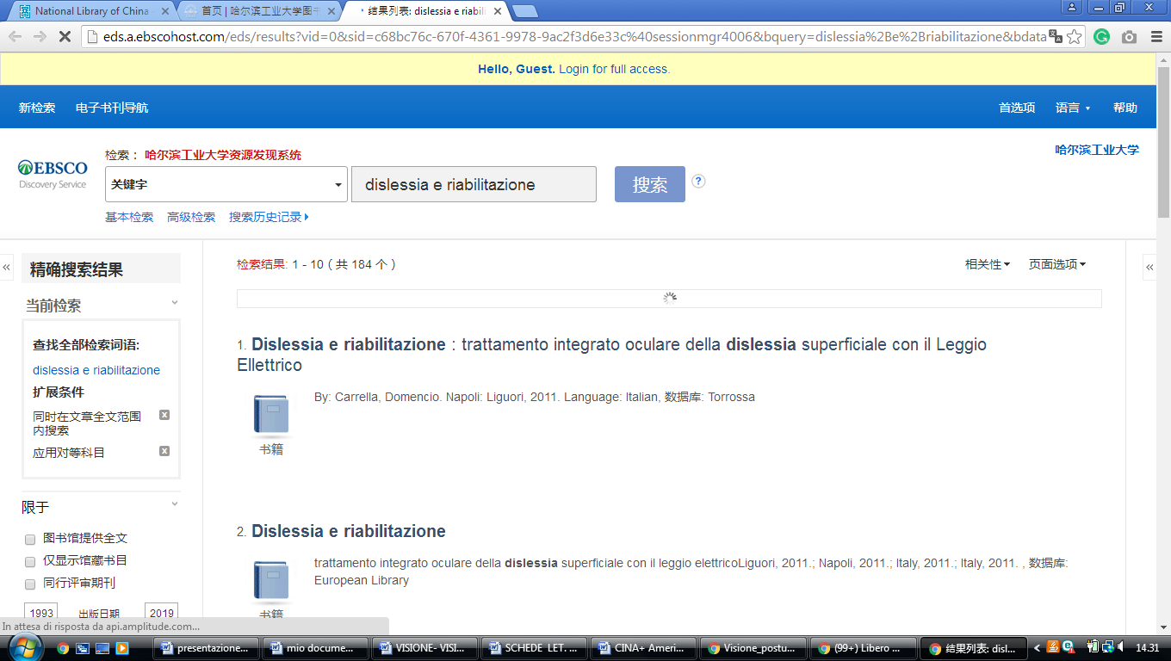

27 [Tianjin Normal University Library](http://tsg.tjnu.edu.cn/)

[http://en.tjnu.findplus.cn/?h=search\_list&query=dislessia%20e%20riabilitazione&action[addexpander][]=fulltext](http://en.tjnu.findplus.cn/?h=search_list&query=dislessia%20e%20riabilitazione&action%5baddexpander%5d%5b%5d=fulltext)

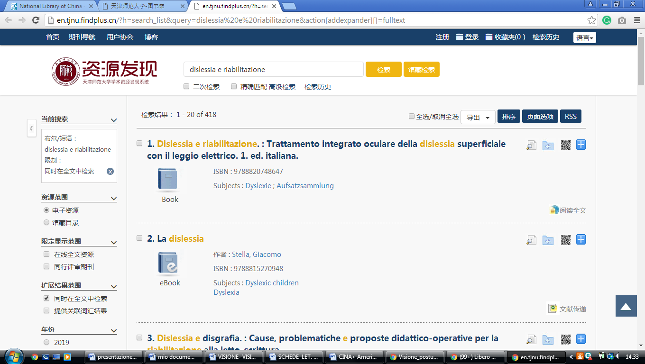

27 [South China Agricultural University Library](http://lib.scau.edu.cn/)

[http://scau.summon.serialssolutions.com/search?s.q=dislessia%20e%20riabilitazione#!/search?ho=f&l=zh-CN&q=dislessia%20e%20riabilitazione](http://scau.summon.serialssolutions.com/search?s.q=dislessia%20e%20riabilitazione%23!/search?ho=f&l=zh-CN&q=dislessia%20e%20riabilitazione)

**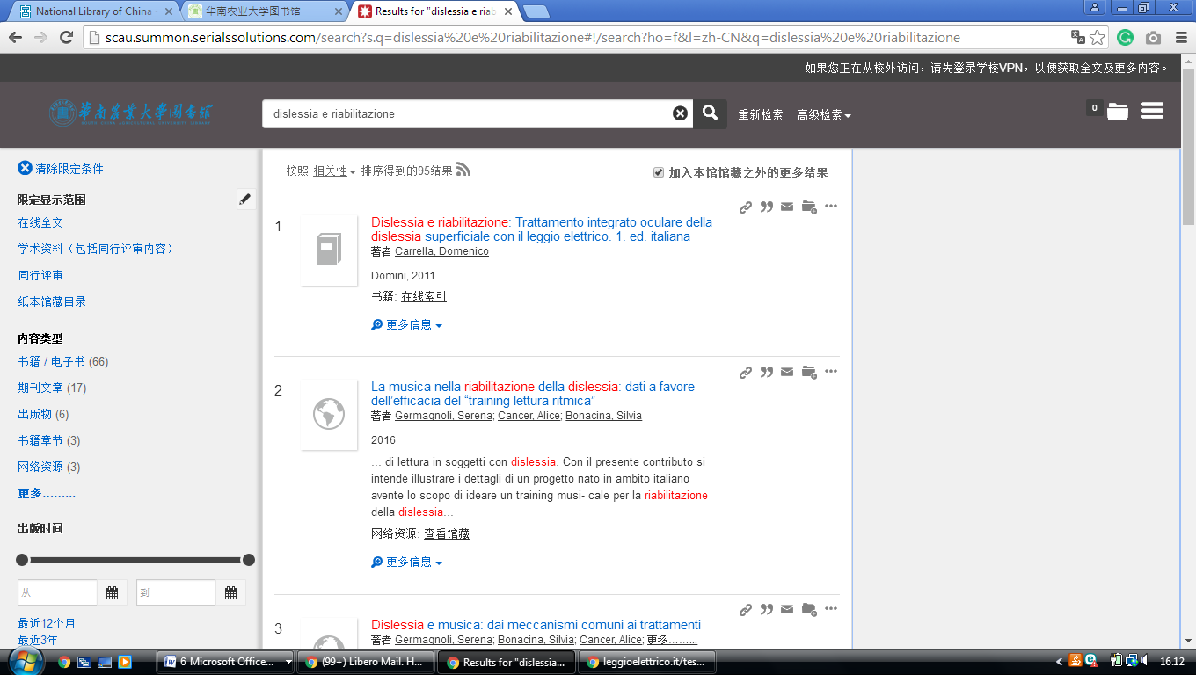**

28 [Seton Hall University Libraries](http://library.shu.edu/)

<https://setonhall.worldcat.org/search?q=dislessia+e+riabilitazione&qt=notfound_page&scope=0&oldscope=2&search=Chercher>

**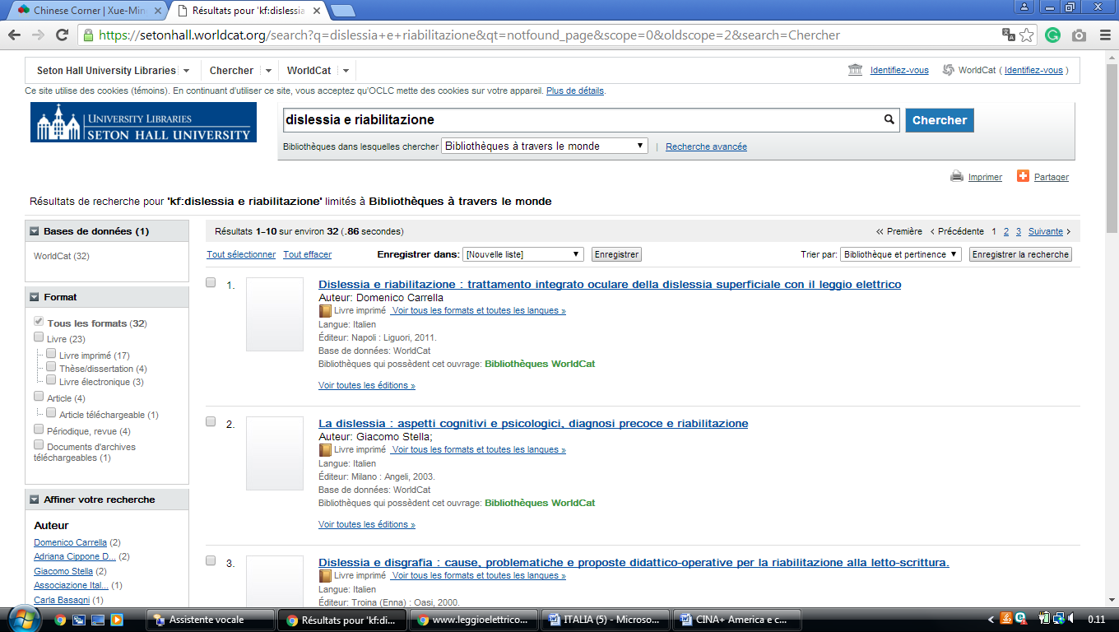**

29 The Medical Library Of Shanghai Jiao Tong University

<http://xueshu.baidu.com/usercenter/paper/show?paperid=d30858067c08627b6134cab38ca7534e&site=xueshu_se&hitarticle=1>

<http://xueshu.baidu.com/s?wd=dislessia+e+riabilitazione>

<http://xueshu.baidu.com/s?wd=dislessia+e+riabilitazione&rsv_bp=0&tn=SE_baiduxueshu_c1gjeupa&rsv_spt=3&ie=utf-8&f=8&rsv_sug2=1&sc_f_para=sc_tasktype%3D%7BfirstSimpleSearch%7D>

**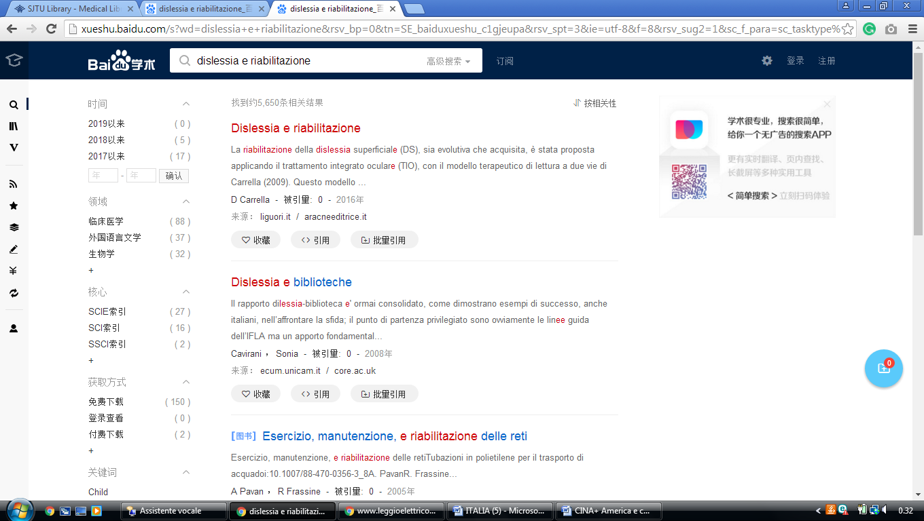**

30 [University of Macau](http://library.umac.mo/lib.html) (CINA)

<https://umac-primo.hosted.exlibrisgroup.com/primo-explore/search?institution=853UOM&vid=853UOM&tab=default_tab&search_scope=default_scope&mode=basic&displayMode=full&bulkSize=10&highlight=true&dum=true&query=any,contains,dislessia%20e%20riabilitazione&displayField=all&pcAvailabiltyMode=true&sortby=rank&lang=en_US&pcAvailability=true>

