**[INSTITUT SUPÉRIEUR DU SAHEL (ISS) DE L’UNIVERSITÉ DE MAROUA](https://www.wipo.int/tisc/en/search/details.jsp?id=8358), CAMERUN**

[Online catalogue LIBRARY OF IPRC Kigali - IPRC MIS](https://www.google.com/url?sa=t&rct=j&q=&esrc=s&source=web&cd=5&ved=2ahUKEwjV56Cf4YbpAhWeAWMBHTGYBMIQFjAEegQIBRAB&url=http%3A%2F%2Fmis.iprckigali.ac.rw%3A82%2Fhtml%2Flibrary%2Fopac_css%2Findex.php%3Flvl%3Dcateg_see%26id%3D469&usg=AOvVaw3pJ5tN30vZ3qDpbELpk55d)

[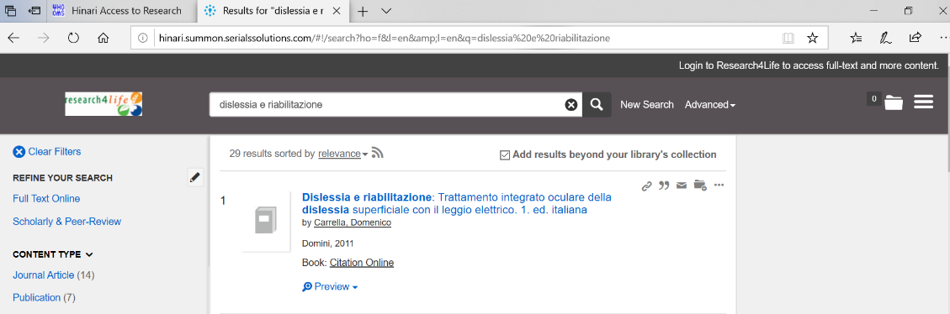](https://www.google.com/url?sa=t&rct=j&q=&esrc=s&source=web&cd=5&ved=2ahUKEwjV56Cf4YbpAhWeAWMBHTGYBMIQFjAEegQIBRAB&url=http%3A%2F%2Fmis.iprckigali.ac.rw%3A82%2Fhtml%2Flibrary%2Fopac_css%2Findex.php%3Flvl%3Dcateg_see%26id%3D469&usg=AOvVaw3pJ5tN30vZ3qDpbELpk55d)