**14.** [**BIBLIOTHÈQUE NATIONALE DU BURKINA FASO**](http://www.culture.gov.bf/)

[Ressources numériques - Université Saint Thomas d'Aquin ...](https://www.google.com/url?sa=t&rct=j&q=&esrc=s&source=web&cd=9&cad=rja&uact=8&ved=2ahUKEwiLqKyihv3oAhXsxMQBHVmNCvAQFjAIegQICRAB&url=https%3A%2F%2Fwww.usta.bf%2Fspip.php%3Farticle50&usg=AOvVaw1cGhgJH-jz7xe70D3drpBq&cshid=1587593465139256)

[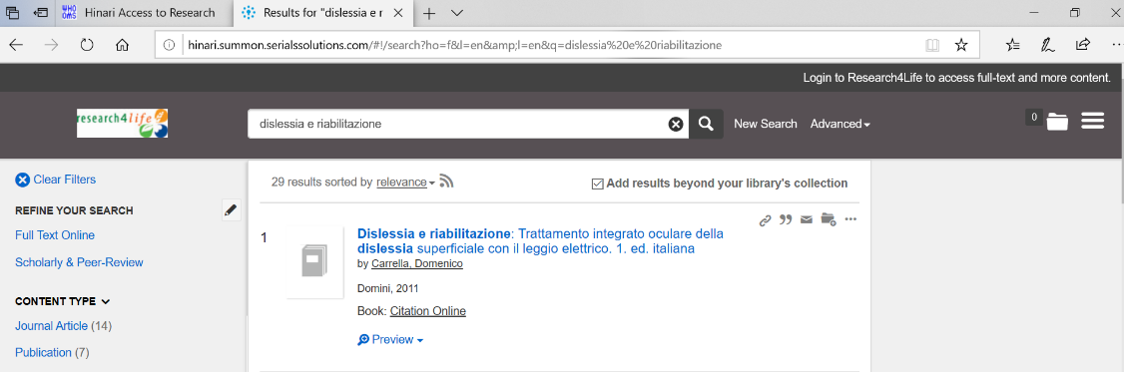](https://www.google.com/url?sa=t&rct=j&q=&esrc=s&source=web&cd=9&cad=rja&uact=8&ved=2ahUKEwiLqKyihv3oAhXsxMQBHVmNCvAQFjAIegQICRAB&url=https%3A%2F%2Fwww.usta.bf%2Fspip.php%3Farticle50&usg=AOvVaw1cGhgJH-jz7xe70D3drpBq&cshid=1587593465139256)