**. UNIVERSITÉ DE BRETAGNE OCCIDENTALE, Plouzané, BO**

[Bibliothèque La Pérouse - Ifremer](https://www.google.com/url?sa=t&rct=j&q=&esrc=s&source=web&cd=1&cad=rja&uact=8&ved=2ahUKEwj8vuGg_8zoAhXGKewKHT2cDB4QFjAAegQIChAC&url=https%3A%2F%2Fwwz.ifremer.fr%2Fblp%2F&usg=AOvVaw0-7qQ1NBunX2nHFfSDV0s7)

[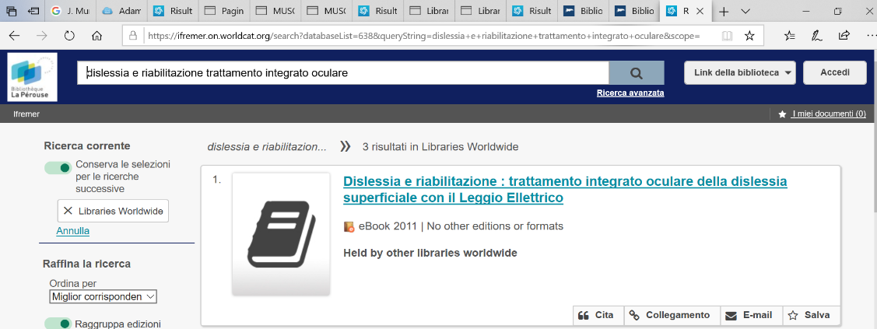](https://www.google.com/url?sa=t&rct=j&q=&esrc=s&source=web&cd=1&cad=rja&uact=8&ved=2ahUKEwj8vuGg_8zoAhXGKewKHT2cDB4QFjAAegQIChAC&url=https%3A%2F%2Fwwz.ifremer.fr%2Fblp%2F&usg=AOvVaw0-7qQ1NBunX2nHFfSDV0s7)