### 1 [WELCOME TO THE BU LIBRARIES! » BU LIBRARIES | BOSTON UNIVERSITY](http://www.bu.edu/library/news/2011/08/18/welcome-to-the-bu-libraries-3/) - (Belgio)

<https://buprimo.hosted.exlibrisgroup.com/primo-explore/search?query=any,contains,dislessia%20e%20riabilitazione&tab=worldcat&search_scope=WorldCat&vid=BU&lang=en_US&offset=0>

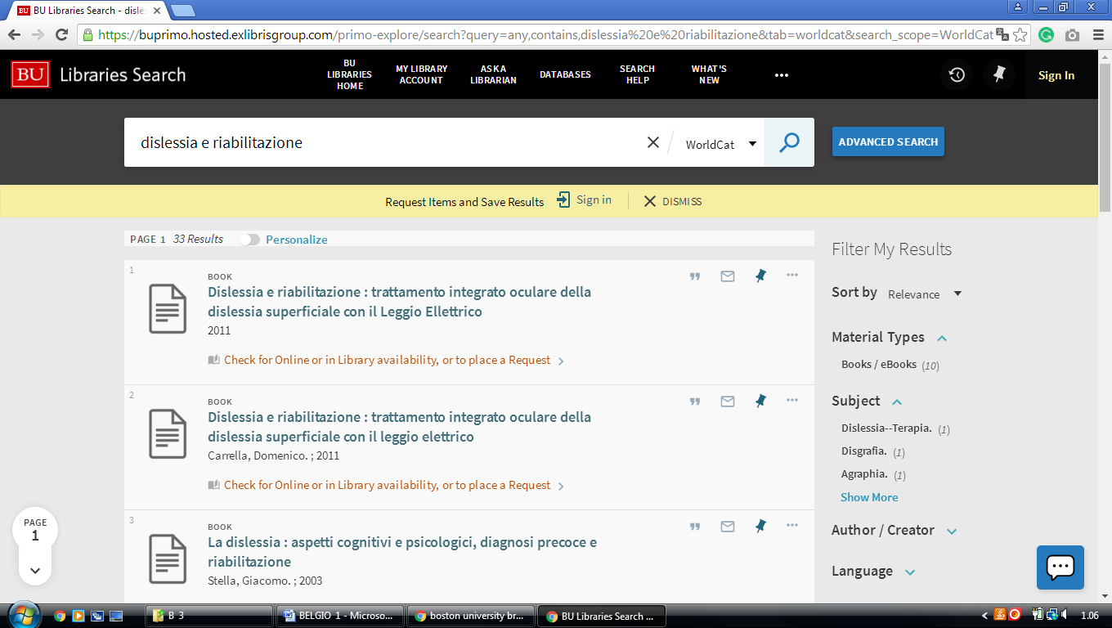

**2** [**EUROPEAN COMMISSION CENTRAL LIBRARY**](http://ec.europa.eu/libraries/index_en.htm) **– (**Brussels, Belgio)

<https://ec-europa-finder.hosted.exlibrisgroup.com/primo-explore/search?query=any,contains,%20dislessia%20e%20riabilitazione&search_scope=default_scope&sortby=rank&vid=32EUC_VU1&lang=en_US&pcAvailability=true>

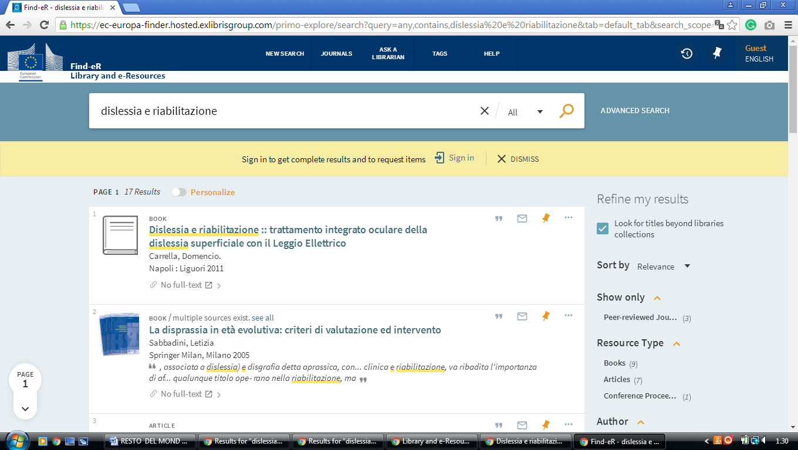

### 3 [GHENT UNIVERSITY LIBRARY - THE EUROPEAN LIBRARY](http://www.theeuropeanlibrary.org/tel4/contributor/P01378) - (Belgio)

<http://www.theeuropeanlibrary.org/tel4/contributor/P01378>

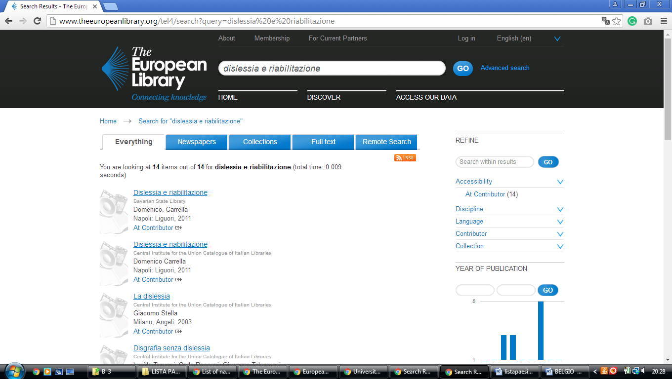

[UHasselt | University Library](https://bibliotheek.uhasselt.be/en)

https://uha.summon.serialssolutions.com/?#!/search?ho=f&l=en&q=dislessia%20e%20riabilitazione

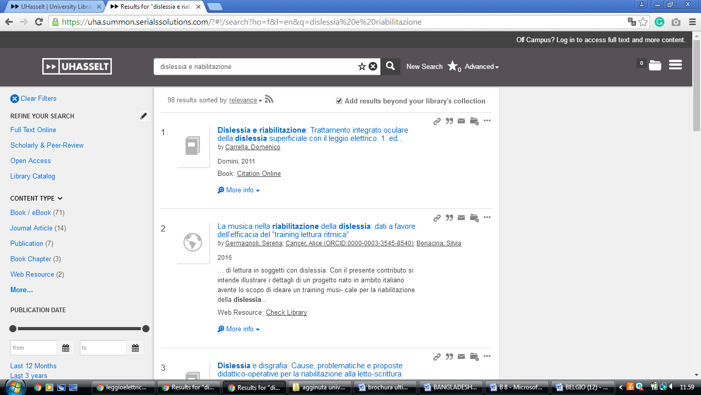

**Bibliotheek van het Federaal Parlement Belgian Parliament**

https://limo.libis.be/primo-explore/search?query=any,contains,dislessia%20e%20riabilitazione&tab=all_content_tab&search_scope=ALL_CONTENT&vid=KULeuven&lang=en_US&offset=0&pcAvailability=true

