**1** [**UNIVERSITY OF APPLIED ARTS VIENNA**](http://bibserver.uni-ak.ac.at/hbaw/einstieg.html) **BIBLIOTHEK KATALOGE**

(Vienna, Austria)

<http://search.obvsg.at/primo_library/libweb/action/display.do?tabs=detailsTab&ct=display&fn=search&doc=TN_casalini_libriit02503952&indx=1&recIds=TN_casalini_libriit02503952&recIdxs=0&elementId=0&renderMode=poppedOut&displayMode=full&frbrVersion=&vl(7407654UI0)=any&pcAvailabiltyMode=true&query=any%2Ccontains%2C+dislessia+e+riabilitazione&vl(1UI0)=contains&dscnt=0&search_scope=Katalog_PrimoCentral&scp.scps=scope%3A%28KAW_aleph_acc%29%2Cscope%3A%28KAW_O_metalib%29%2Cscope%3A%28KAW_O_sfx%29%2Cprimo_central_multiple_fe&vid=KAW&highlight=true&institution=KAW&queryTemp=+dislessia+e+riabilitazione&tab=katalog_primocentral&displayField=title&fromDL=&vl(freeText0)=%20dislessia%20e%20riabilitazione&dstmp=1497328190762>

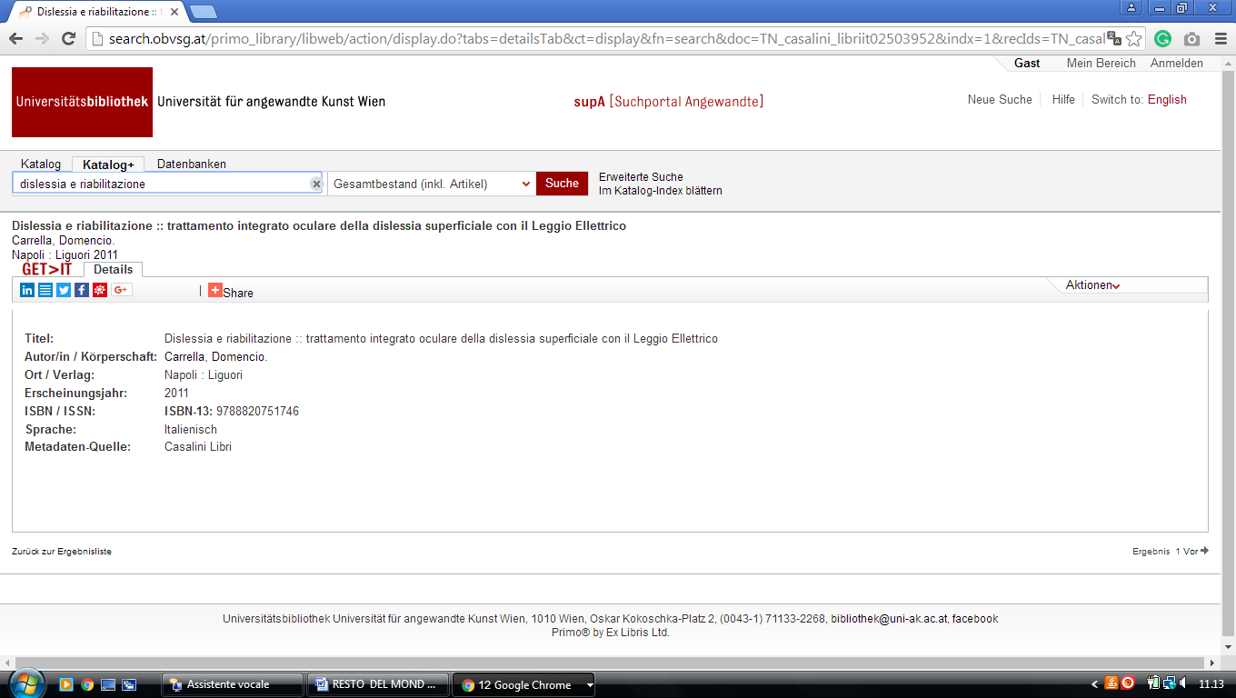

Leoben University Library  
Montanuniversität Leoben

**Leoben University**  
[**Leoben**](https://librarytechnology.org/libraries/search.pl?City=Leoben&Country=Austria), Styria  
  
https://unileoben.summon.serialssolutions.com/search?s.q=dislessia%20e%20riabilitazione&spellcheck=true#!/search?ho=f&l=it-IT&q=dislessia%20e%20riabilitazione

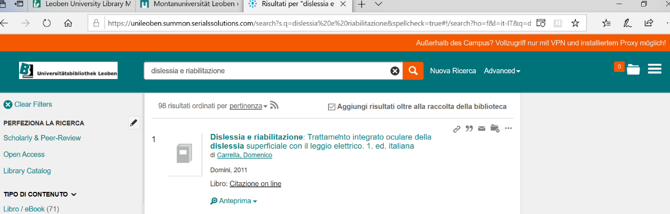

Verbund für Bildung und Kultur

**Pädagogischen Hochschule Tirol**

#### Address: Strozzigasse 2 [Vienna](https://librarytechnology.org/libraries/search.pl?City=Vienna&Country=Austria),

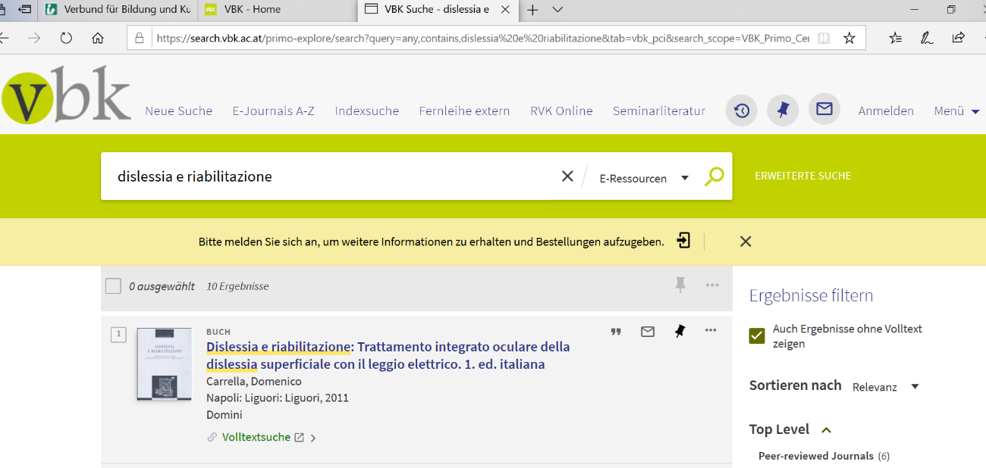https://search.vbk.ac.at/primo-explore/search?query=any,contains,dislessia%20e%20riabilitazione&tab=vbk_pci&search_scope=VBK_Primo_Central&vid=VBK&lang=de_DE&offset=0&pcAvailability=true

**UNIVERSITY OF APPLIED SCIENCES VORARLBERG AUSTRIA**

FH Vorarlberg Bibliothek

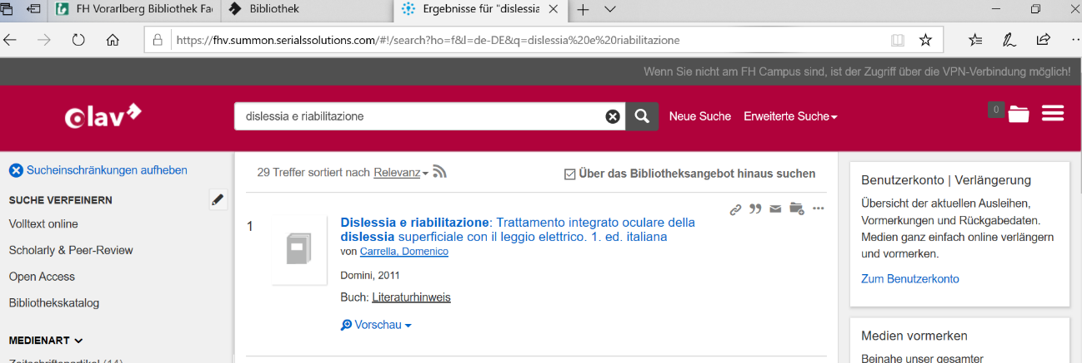https://fhv.summon.serialssolutions.com/#!/search?ho=f&l=de-DE&q=dislessia%20e%20riabilitazione