### 1 [AUA'S AGBU PAPAZIAN LIBRARY - AMERICAN UNIVERSITY OF ARMENIA](http://library.aua.am/), (Armenia)

<https://aualibrary.on.worldcat.org/search?sortKey=BEST_MATCH&databaseList=&queryString=DISLESSIA+E+RIABILITAZIONE&changedFacet=scope&scope=&scope=sz%3A36210&scope=wz%3A48498&format=all&database=all&author=all&year=all&yearFrom=&yearTo=>

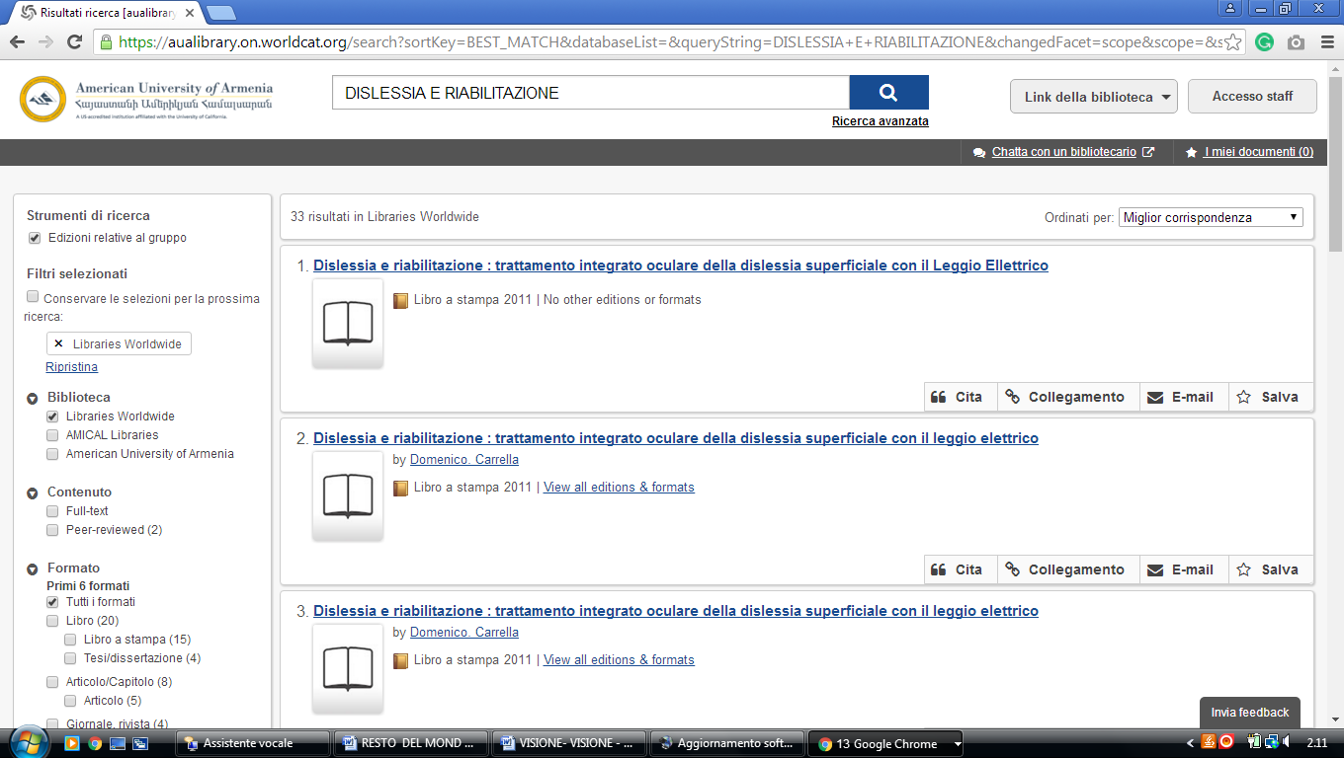

### 2 [NATIONAL LIBRARY OF ARMENIA - THE EUROPEAN LIBRARY](http://www.theeuropeanlibrary.org/tel4/contributor/P01194) (Armenia)

<http://www.nla.am/arm/index.php>

