**1** [**ALFAISAL UNIVERSITY LIBRARY**](http://lib.alfaisal.edu/)  - (Kingdom of Saudi Arabia, KSA)

[http://alfaisal.summon.serialssolutions.com/search?s.q=dislessia+e+riabilitazione#!/search?ho=f&l=en&q=dislessia%20e%20riabilitazione](http://alfaisal.summon.serialssolutions.com/search?s.q=dislessia+e+riabilitazione%23!/search?ho=f&l=en&q=dislessia%20e%20riabilitazione)

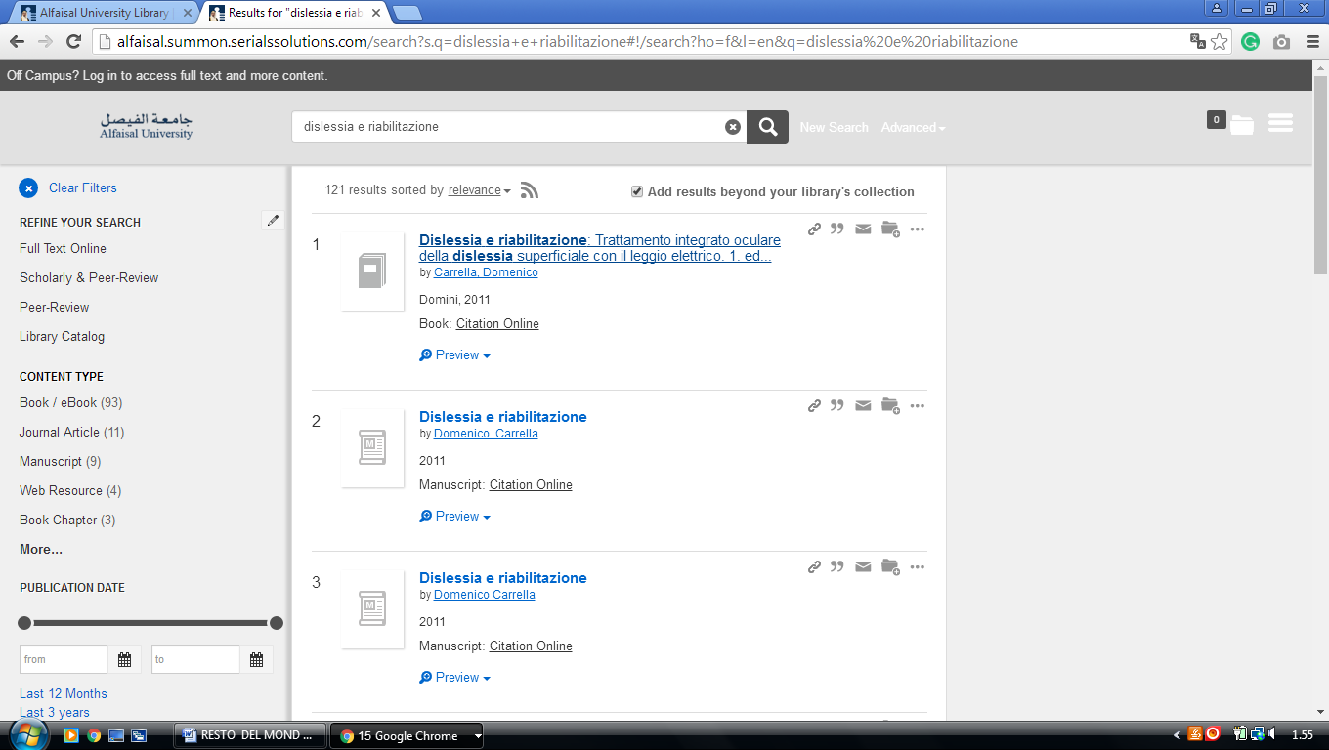

**2 LIBRARY KING ABDULLAH UNIVERSITY OF SCIENCE AND TECHNOLOGY** (Kaust)

<https://koral.summon.serialssolutions.com/#!/search?ho=f&l=en&q=DISLESSIA%20E%20RIABILITAZIONE>

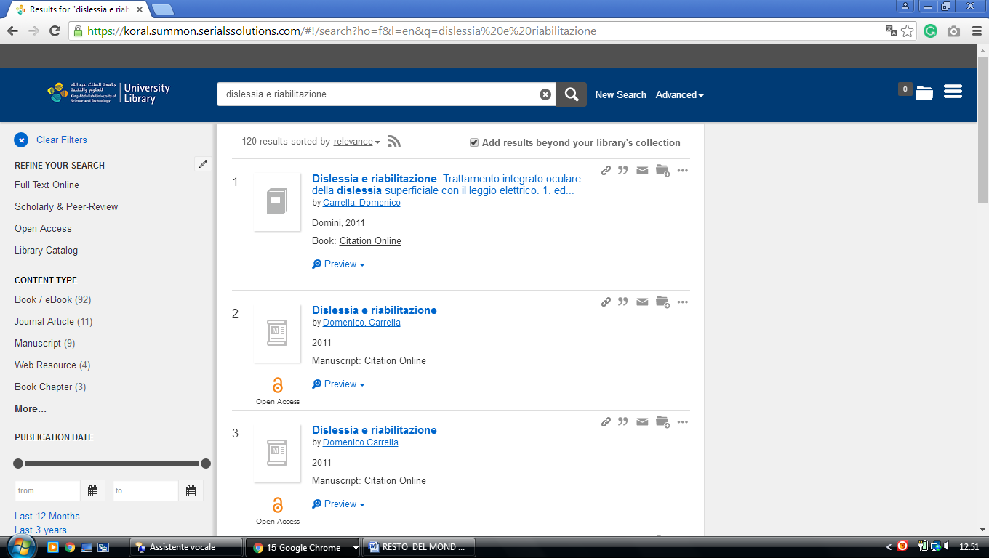

### 3. Bibliothèque King Abdullah University of Science and Technology (KAUST)

### https://koral.summon.serialssolutions.com/#!/search?ho=f&l=en&q=dislessia%20e%20riabilitazione

### 

### [4. Saudi Digital Library - المكتبة الرقمية السعود4 Jazan University, Arabia SAUDITA](https://sdl.edu.sa/sdlportal/en/publishers.aspx)

### http://eds.a.ebscohost.com/eds/results?vid=1&sid=72200209-0265-4b04-aeec-20d8d2c150be%40sessionmgr4006&bquery=dislessia+e+riabilitazione&bdata=JnR5cGU9MCZzZWFyY2hNb2RlPUFuZCZzaXRlPWVkcy1saXZl

### 

**5. king saud university,** [**Saudi Digital Library - المكتبة الرقمية**](https://sdl.edu.sa/sdlportal/en/publishers.aspx)

Open acces

http://eds.a.ebscohost.com/eds/results?vid=1&sid=c27f6802-8a40-4cd5-80a0-5db432522d61%40sessionmgr4008&bquery=dislessia+e+riabilitazione&bdata=JnR5cGU9MCZzZWFyY2hNb2RlPUFuZCZzaXRlPWVkcy1saXZl

