**1** [**DEPARTMENT OF LIBRARY SERVICES**](http://www.library.up.ac.za/) **-** (Pretoria, Angola)

[https://univofpretoria.on.worldcat.org/search?sortKey=LIBRARY&databaseList=&queryString=dislessia+e+riabilitazione&changedFacet=scope&scope=&scope=sz%3A33860&format=all&database=all&author=all&year=all&yearFrom=&yearTo=#/oclc/878784487](https://univofpretoria.on.worldcat.org/search?sortKey=LIBRARY&databaseList=&queryString=dislessia+e+riabilitazione&changedFacet=scope&scope=&scope=sz%3A33860&format=all&database=all&author=all&year=all&yearFrom=&yearTo=" \l "/oclc/878784487)

[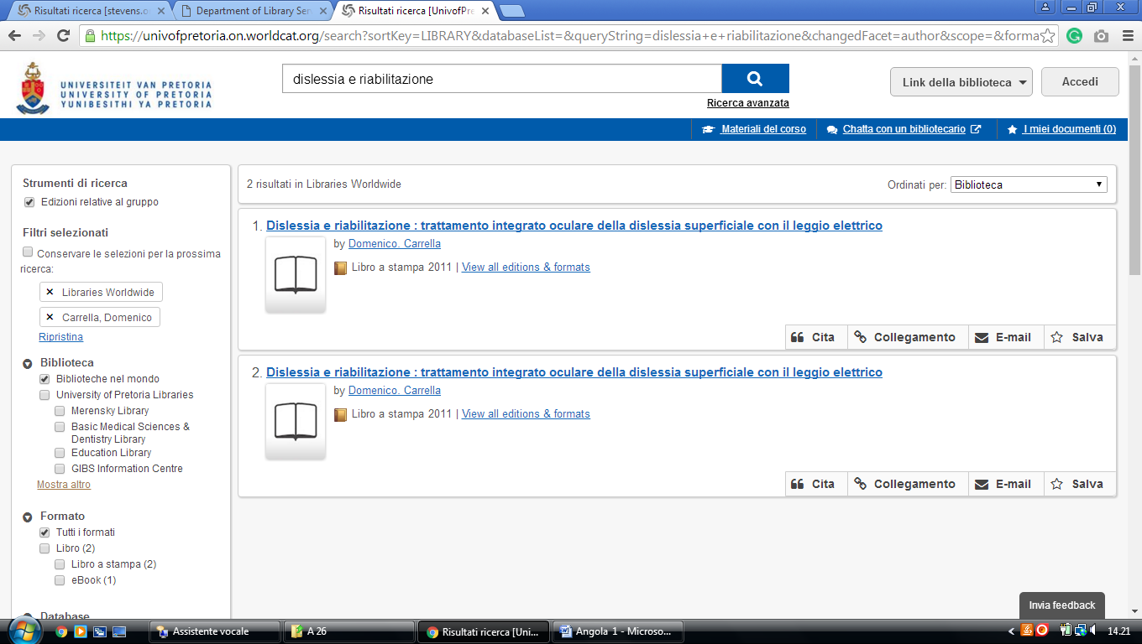](https://univofpretoria.on.worldcat.org/search?sortKey=LIBRARY&databaseList=&queryString=dislessia+e+riabilitazione&changedFacet=scope&scope=&scope=sz%3A33860&format=all&database=all&author=all&year=all&yearFrom=&yearTo=" \l "/oclc/878784487)